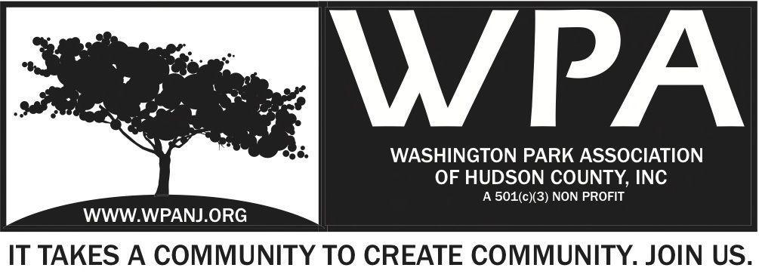
Board of Trustees
Bob Boudreau – President
Jay McVey – Vice President
Anthony Collet – Treasurer
Terri Neuner – Secretary
Lisa Blando – Trustee
Louis Fernandez – Trustee
Erin Kumpf – Trustee
Wendy Paul – Trustee
Walter Rodriguez – Trustee
Mory Thomas - Trustee

WPA Special Trustee - Meeting Agenda
March 31, 2016
7:30pm – 9:00pm
237 South St – Jersey City, NJ 07307
Time | Item
7:30-7:35  7:35-7:40  7:40-8:55  8:55-9:00 | Welcome and Attendance  WPA By- Laws  Committee Updates and Collaboration  - IT/ Website/ Communication  - Fundraising/ Grants  - Sponsorship Packet  - Art/ Music Events  - Post discussion - March 11  Momentum Event  - Upcoming Momentum dates  - WPA Live - Alternate event dates  - Park Activities/ Events/ Education  - Green Acres  - GS Day  - Annual Planting in the Park  - Nomination Committee/ Community Engagement  - Heights Civic Engagement Outreach April 10  - RJF Event Sponsorship  - Buildings/ Zoning/ Development  Last Comments - Adjourn

