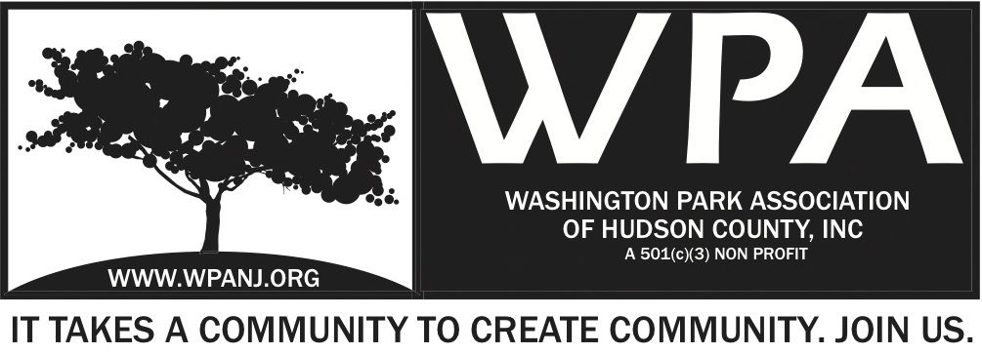
WPA General Monthly Meeting
Location: 155 North St, Jersey City, NJ 07307
Date: Monday, June 03, 2019
Time: 7:30pm- 9:00pm
Board of Trustees Attending Y / N
Mory Thomas – President
Nick Lawrence Treasurer
Nick Caballero Secretary
Andrea Brachfeld Trustee
Tim Brown – Trustee
Hector Fermin – Trustee
Starr James - Trustee
Jay McVey – Trustee
Yolanda Miranda Trustee
Katherine Parker Trustee
Wendy Paul Trustee
Vacancy - Trustee

Meeting called by: WPA Board of Trustees / Bring Sitting Fee

Type of Meeting: General Monthly Meeting

Facilitator: Mory Thomas
Minute Taker: Nick Caballero

Timekeeper: Nick Caballero

Attendees: WPA Board of Trustees (See sign-in sheet/ Mailing List)

7:30PM - Welcome
- Call to order
- Welcome visitors and general membership **Please sign in**
- Reading of WPA mission statement and rules of conduct
Present Trustee to read
- Trustee Roll Call
- Ratify Minutes – The minutes from the WPA General Monthly Meeting Minutes held on Mondays, March 11, 2019, April 1, 2019 and May 6, 2019 general Monthly Meeting were uploaded to the WPA website, but not in time for review by the WPA Board, are there any omissions or changes needed, If not the minutes are ratified.

7:35PM - Officer Reports

- President’s Report – Mory Thomas
- Treasurer’s Report – Nick Lawrence
- Secretary’s Report – Nick Caballero

7:45PM - Jersey City Heights Crime Statistics and Areas of concern to be addressed
- JCPD
- Resident’s Response / Quality of Life

Old Business / Motion Tabled

7:50PM – WPA Logo and branding discussion / Mory Thomas

Motion Tabled – Motion to discuss and rebrand the WPA logo. Second Nick Lawrence

- Updates –

8:10PM - WPA Annual Sponsorship –

8:20PM - Green Acres Update
- Voucher for 50% of Signage production has been created and signed by WPA and the County and Sign company and submitted for payment.

8:25PM - Earth Mother For You Summer maintenance program / ?

8:30PM – WPW –

8:40PM - Dog Run
- Meeting will be scheduled in the next two weeks to begin planning and design conversations.

8:50PM - WPA Nomination Committee - As stated in the WPA Bylaws the WPA President shall appoint a nomination committee comprised of 2 WPA Trustees and 1 person from the general membership. There shall be 1 general membership alternate and 1 WPA trustee alternate.
- 2019 Nomination Committee Trustees Nick Lawrence, Nick Caballero and Kate Parker Alternate, General Membership Jennifer Lozada and Alternate Laura Santo

WPA Bylaws ARTICLE IV – BOARD OF TRUSTEES
All powers of the WPA shall be exercised by or under the authority of the Board, and the activities, property and affairs of WPA shall be managed by or under the direction of the Board. The Board may exercise all such powers and may delegate any and all such powers as it sees fit, subject to restrictions imposed by the Certificate of Incorporation, these Bylaws, the New Jersey Nonprofit Corporation Act and Section 501(c)(3) of the Internal Revenue Code.
Eligibility
Trustees shall be at least 18 years and residents of the County of Hudson, NJ. All trustees will be expected to enter into a statement of understanding with the WPA regarding their roles and responsibilities as trustees.

9PM Adjourned
WPA Mission Statement:

The objective of the Washington Park Association (WPA) is to work with the community to revitalize, maintain and protect Washington Park in Hudson County, New Jersey and promote its use through the development of programs and activities that enhance the quality of life of park users and local residents

WPA Code of Conduct:

In the interest of fostering community relations and assuring the on-going health of the “WPA”, all meetings will maintain an atmosphere of courtesy and civil conduct. When there is a disagreement of any kind, people will address each other with respect. An individual’s presence at a meeting indicates acceptance of this policy. Anyone whose words or actions go against the policy may be required to leave a meeting

