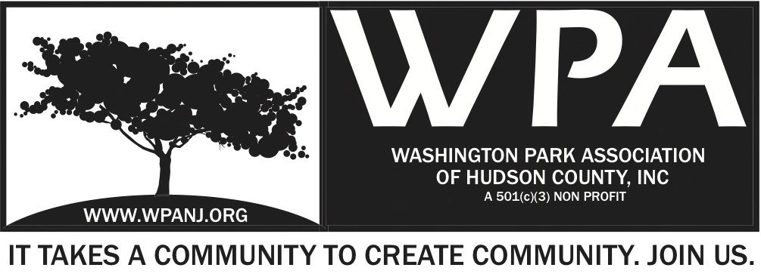
Board of Trustees
Andrea Brachfeld – President
Terri Neuner – Treasurer
Mory Thomas – Secretary
George Fujioka – Trustee
Erin Kumpf – Trustee
Wendy Paul – Trustee
Jay McVey – Trustee
Mory Thomas – Trustee
Federico Nealon - Trustee

WPA General Monthly Meeting

Location: St. John’s Lutheran Church - 155 North St. Jersey City, NJ 07307
January 9, 2017
Time: 7:30pm- 9:00pm
Time | Item | Owner
7:30pm  5 Mins | Welcome  - Call to order  - Welcome visitors and general membership **Please sign in**  - Reading of WPA mission statement and rules of conduct  Present Trustee to read  - Trustee Roll Call  - Ratify Minutes | Terri Neuner
7:35pm  10 Mins | Officer Reports  - President Report  - Treasurer Report  - Secretary Report | Andrea Brachfeld  Terri Neuner  Mory Thomas
7:45pm  10 Mins | Jersey City Heights Crime Statistics  - JCPD  - Residents Response / Quality of Life | JCPD/ RRC
7:55pm  10 Mins | Green Acres / Picnic Area Updates | Nick Caballero
8:05pm  10 Mins | WPA 2017 Sponsorship Packet  - Board actions / responsibilities | Open Discussion Board
8:15pm  25 Mins | Upcoming Events  - Meditation – Sattva Yogo – To begin January 22  - Budget  - Event Promotion  - Execution / Action Items  - Mardi Gras Fund Raising Dinner - February 28th  - Potential Locations  - Format  - Budget  - Execution/ Action Items | Open Discussion Board
8:40pm  10 Mins | WPA Website  - 2017 Programming Updates  - Additional critical updates needed  - Schedule Maintenance/ Updating session – George to assist | Open Discussion Board
8:50pm  5 Mins  8:55pm  9:00pm | WPA Storage Unit  - Inventory January 14 – 3pm  - Discuss other storage options  Closing Comments  Adjourn | Open Discussion Board

