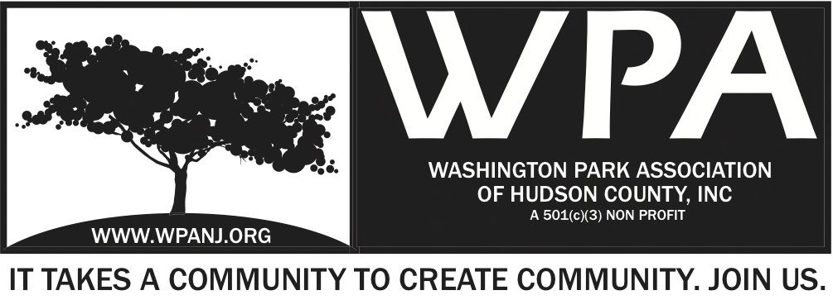
Board of Trustees
Andrea Brachfeld – President
Terri Neuner – Treasurer
Mory Thomas – Secretary
George Fujioka – Trustee
Erin Kumpf – Trustee
Wendy Paul – Trustee
Jay McVey – Trustee
Nick Lawrence – Trustee
Federico Nealon - Trustee

WPA General Monthly Meeting

Location: St. John’s Lutheran Church - 155 North St. Jersey City, NJ 07307
February 6, 2017
Time: 7:30pm- 9:00pm
Time | Item | Owner
7:30pm  5 Mins | Welcome  - Call to order  - Welcome visitors and general membership **Please sign in**  - Reading of WPA mission statement and rules of conduct  Present Trustee to read  - Trustee Roll Call  - Ratify Minutes | Terri Neuner
7:35pm  10 Mins | Officer Reports  - President Report  - Treasurer Report  - Secretary Report | Andrea Brachfeld  Terri Neuner  Mory Thomas
7:45pm  10 Mins | Jersey City Heights Crime Statistics  - JCPD  - Residents Response / Quality of Life | JCPD/ RRC
7:55pm  10 Mins | JC Municipal Court | Stacey Dix-Kielbiowski
8:05pm  10 Mins | Safe Streets JC | Kara Hrabosky
8:15pm  5 Mins  8:20pm  10 Mins  8:30pm  25 Mins | Heights Votes  Updates  - Green Acres – Picnic Area  - WPA Website  Upcoming Event  - Mardi Gras Fund Raising Dinner - February 28th  - Food  - Format  - Budget  - Sponsors  - Execution/ Action Items | Brian Rans  Nick Caballero  Mory/ George  Open Discussion Board
9:00pm | Adjourn

WPA Mission Statement:

The objective of the Washington Park Association (WPA) is to work with the community to revitalize, maintain and protect Washington Park in Hudson County, New Jersey and promote its use through the development of programs and activities that enhance the quality of life of park users and local residents.

WPA Code of Conduct:

In the interest of fostering community relations and assuring the on-going health of the “WPA”, all meetings will maintain an atmosphere of courtesy and civil conduct. When there is a disagreement of any kind, people will address each other with respect. An individual’s presence at a meeting indicates acceptance of this policy. Anyone whose words or actions go against the policy may be required to leave a meeting

