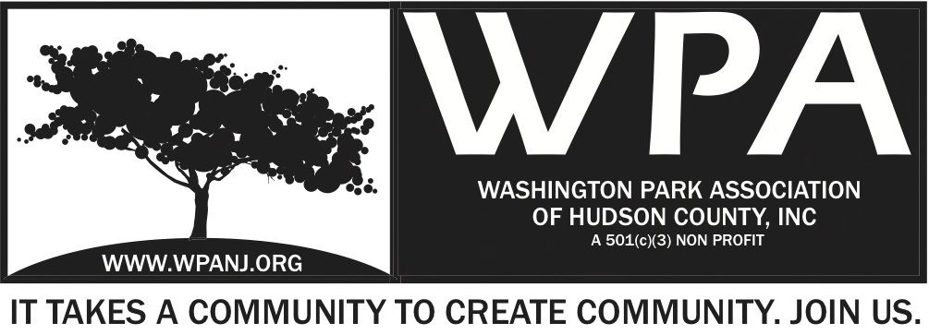
Board of Trustees
Andrea Brachfeld – President
Terri Neuner – Treasurer
Mory Thomas – Secretary
George Fujioka – Trustee
Erin Kumpf – Trustee
Wendy Paul – Trustee
Jay McVey – Trustee
Nick Lawrence – Trustee
Federico Nealon - Trustee

WPA General Monthly Meeting

Location: St. John’s Lutheran Church - 155 North St. Jersey City, NJ 07307
March 6, 2017
Time: 7:30pm- 9:00pm
Time | Item | Owner
7:30pm  5 Mins | Welcome  - Call to order  - Welcome visitors and general membership **Please sign in**  - Reading of WPA mission statement and rules of conduct  Present Trustee to read  - Trustee Roll Call  - Ratify Minutes | Terri Neuner
7:35pm  10 Mins | Officer Reports  - President Report  - Treasurer Report  - Secretary Report | Andrea Brachfeld  Terri Neuner  Mory Thomas
7:45pm  10 Mins | Jersey City Heights Crime Statistics  - JCPD  - Residents Response / Quality of Life | JCPD/ RRC
7:55pm  15 Mins  8:05pm  15 Mins  8:20pm  10 Mins  8:30pm  20 Mins  8:50pm  5 Mins  8:55pm  5 Mins | WPA Fundraising Dinner Series  - Mardi Gras Fund Raising Dinner - Held February 28th  - Recap  - Funds Raised  - Changes / Improvements for next Dinner Event?  Website  - Updates  - Media - Log Ins – Past and present  - Newsletter  Updates  - Green Acres – Picnic Area  Upcoming Events  - Confirm programming dates - WPA Music in the Park Series  - Begin planning  - The Journey  - Cinco De Mayo  Votes:  New Officers to Vote in – (by raise of hand)  Nick Lawrence - Treasurer  Erin Kumpf - Secretary  Erin Kumpf - for WPA Secretary (To replace Mory Thomas)  If voted in, term as WPA Secretary will expire November 5. 2018.  Nick Lawrence- for WPA Treasurer (To replace Terri Neuner)  If voted in, term as WPA Treasurer will expire November 6, 2017.  Final Notes / Follow up items | Nick C/ George  George/ Andrea  Nick  All
9:00pm | Adjourn  WPA Mission Statement:  The objective of the Washington Park Association (WPA) is to work with the community to revitalize, maintain and protect Washington Park in Hudson County, New Jersey and promote its use through the development of programs and activities that enhance the quality of life of park users and local residents.  WPA Code of Conduct:  In the interest of fostering community relations and assuring the on-going health of the “WPA”, all meetings will maintain an atmosphere of courtesy and civil conduct. When there is a disagreement of any kind, people will address each other with respect. An individual’s presence at a meeting indicates acceptance of this policy. Anyone whose words or actions go against the policy may be required to leave a meeting

