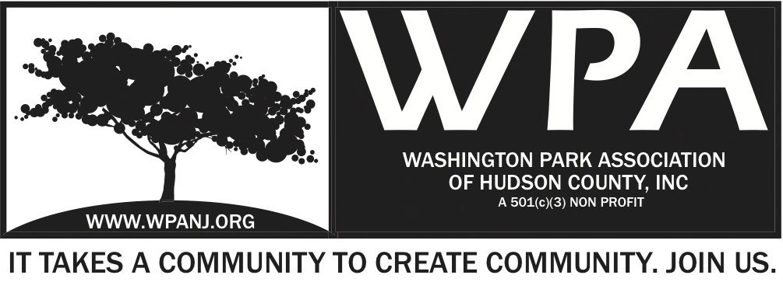
Board of Trustees
Andrea Brachfeld – President
Nick Lawrence - Treasurer
Erin Kumpf - Secretary
Terri Neuner – Trustee
Mory Thomas – Trustee
Federico Nealon - Trustee
George Fujioka – Trustee
Wendy Paul – Trustee
Jay McVey – Trustee
Nick Lawrence – Trustee
Federico Nealon - Trustee

WPA General Monthly Meeting

Location: St. John’s Lutheran Church - 155 North St. Jersey City, NJ 07307
May 1, 2017
Time: 7:30pm- 9:00pm
Time | Item | Owner
7:30pm  5 Mins | Welcome  - Call to order  - Welcome visitors and general membership **Please sign in**  - Reading of WPA mission statement and rules of conduct  Present Trustee to read  - Trustee Roll Call  - Ratify Minutes | Erin Kumpf
7:35pm  10 Mins | Officer Reports  - President Report  - Treasurer Report  - Secretary Report | Andrea Brachfeld  Nick Lawrence  Erin Kumpf
7:45pm  10 Mins | Jersey City Heights Crime Statistics  - JCPD  - Residents Response / Quality of Life | JCPD/ RRC
7:55pm  15 Mins  8:10pm  5 Mins  8:15pm  25 Mins  8:40pm  20 Mins | WPA Fundraising Dinner Series  - Cinco De Mayo Fund Raising Dinner - May 3rd  - Organization  - Silent Auction/ 50/50  - Distribution of duties  Website  - Updates  - Newsletter  - Promotion  Updates and Planning  - Green Acres – Picnic Area  - Ribbon Cutting  - Events – Music – Kids Activities – Food  - Brian Stack update  - The Journey  - Planting in the Park  - Volunteers – Youth Corps - Boy Scouts – High Schools  - Distribution of duties  Upcoming Events  - Begin planning  - July 8th Music in the Park  - The Voodudes – Contract needed | All  George/ Andrea  Nick  All
9:00pm | Adjourn  WPA Mission Statement:  The objective of the Washington Park Association (WPA) is to work with the community to revitalize, maintain and protect Washington Park in Hudson County, New Jersey and promote its use through the development of programs and activities that enhance the quality of life of park users and local residents.  WPA Code of Conduct:  In the interest of fostering community relations and assuring the on-going health of the “WPA”, all meetings will maintain an atmosphere of courtesy and civil conduct. When there is a disagreement of any kind, people will address each other with respect. An individual’s presence at a meeting indicates acceptance of this policy. Anyone whose words or actions go against the policy may be required to leave a meeting

