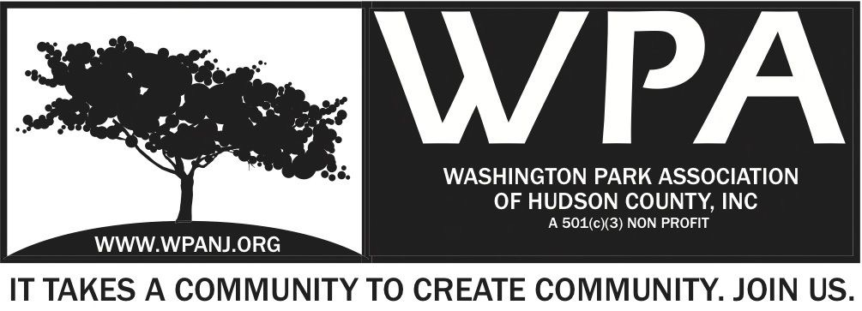
WPA General Monthly Meeting

Location: St. John’s Lutheran Church - 155 North St. Jersey City, NJ 07307
Board of Trustees
Andrea Brachfeld – President
Nick Lawrence– Treasurer
Erin Kumpf – Secretary
George Fujioka – Trustee
Mory Thomas – Trustee
Wendy Paul – Trustee
Jay McVey – Trustee
Federico Nealon - Trustee

September 11, 2017
Time: 7:30pm- 9:00pm
Time | Item | Owner
7:30pm  5 Mins | Welcome  - Call to order  - Welcome visitors and general membership **Please sign in**  - Reading of WPA mission statement and rules of conduct  Present Trustee to read  - Trustee Roll Call  - Ratify Minutes | Andrea Brachfeld/  Erin Kumpf
7:35pm  10 Mins | Officer Reports  - President Report  - Treasurer Report  - Secretary Report | Andrea Brachfeld  Erin Kumpf  Nick Lawrence
7:45pm  5 Mins | Jersey City Heights Crime Statistics  - JCPD  - Residents Response / Quality of Life | JCPD/ RRC
7:50pm  25 Mins | Green Acres/Ribbon Cutting  - Details: Date, bands/contracts, food trucks, etc  - Story of the creation of Washington Park Signage  - Date? | Nick Caballero/Erin Kumpf/Mory Thomas
8:15pm  15 Mins | Signage of 4 Park Locations  - Discuss Possible Names | Andrea Brachfeld/Mory Thomas
8:30pm  15 Mins | Day of the Dead Fundraiser  - Details: Date, possible venue, music, food trucks, etc, | Andrea Brachfeld
8:45pm  5 Mins | Carepoint Presentation Follow Up | Andrea Brachfeld
8:50pm  5 Mins | JCPC/NJTF and TD Bank Washington: City of Trees Plantings in Washington Park  - Vote on to Support purchasing Gator Bags  - Fund Raiser Possibility | Erin Kumpf/Mory Thomas
8:55pm | Adjourn

WPA Mission Statement:

The objective of the Washington Park Association (WPA) is to work with the community to revitalize, maintain and protect Washington Park in Hudson County, New Jersey and promote its use through the development of programs and activities that enhance the quality of life of park users and local residents.

WPA Code of Conduct:

In the interest of fostering community relations and assuring the on-going health of the “WPA”, all meetings will maintain an atmosphere of courtesy and civil conduct. When there is a disagreement of any kind, people will address each other with respect. An individual’s presence at a meeting indicates acceptance of this policy. Anyone whose words or actions go against the policy may be required to leave a meeting

Started at 7:31

Minutes:
Pres report: Success of Music in the Park : voodudues
*we were going to do concert on Aug 12 but we figured with the Green aCres park near, we’d plan for our music event to coincide
*APS donated $200 JCPD for National Night Out
*Federico Nealon and Andrea Brachfeld attended
*communication with Jamie “Kindness Rock” project (Jamie will attend later meeting). Paint rocks throughout the park
*Kona Ice contacted Andrea and is interested with Ribbon Cutting
*Many discussions re: pavers
Treasuerer:
We’re in good standing and paid up for past events.
• Account balance for July
◦ Starting $25,715.65
◦ Closing balance $24,280.36
◦ Deposits:
▪ $75.00 Donation
▪ Interest $1.05
◦ Expenses: $1,540.24
▪ Goodfriend Self-storage - $139.00
▪ Music In the Park - $1,401.24
▪ United Rental $144.48 - 7/10/17
▪ VooDudes - $1,200
▪ Dora Weiss (face painting) - $50
▪ C-Town $6.76

Secretary Report:
Minutes uploaded

7:38-7:40 pm Officer Lopez: Stats
Concerns:
Andrea Brachfeld-on street there is a cone saving a parking spot
Across from 9 Leonard
Officer Lopez: also people painting
Advice: contact city /parking authority to perhaps give warning

7:41PM
Carepoint Presentation:
Ruddys: ext affairs for Carepoint Presentations -
*Community outreach for carping and advise senior execs
*Thanks to Nick, Mory and Wendy
*Always hears positive feedback about our park
*Sam Logan COO for Hoboken University Medical Center-

3 hopsitals: bayone, christ and hoboken (al were in bankruptcy)
*55% of patients are underprivileged
*Is a registered RN
*$$ made for these hospitals go right back into the hospitals
*Buying new equipemnt, giving raises (bc for-profit you don’t usually hear the positive)

Hoboken: Used to be St Marys (154 years old)
*Now its Carepoint Community Hospital
*Medical/surgical/OR/ED
*radiology lab
*psychiatric services
*OB: has done a lot of work/renovations/round the clock docs-wants to bring more patients
-instituted new programs with midwives , water births
-Focus on GYN surgery with robotics
*PAs, Nurse Practitioners

Ruddys: mobile health van-25 different screenings
*sometimes nurse practitioners
*Often go where they don’t have access/not mobile
*Tax paying entire 22million in taxes paid
*larges private employments in hudson county 4K.
*Physician practices
*Meditation for

Andrea: alternative therapies such as music?
-they haven’t yet but doesn’t mean they won’t/can’t

Mory: preventative medicine
*Outreach

Shift from inpatient model to outpatient model

Government funding applied/not applied based on patient satisfaction, infection rate
*based on certain conditions there is formula that determines how long patient should be in hospital
*they are rewarded for making criteria
*Less infections
*Their goal is to make sure they take care of patients, reducing

Heather Wahl (Speranza Theatre)
Women’s theater company: focus on shows that provide opportunities for women (playright, actors, behind secnes0
and that shows they select deal with women’s issues
*do hire men too!
*Non profit company who works with various orgs in JC
*Works with JC Fridays so at least 4 opportunity for shows
*past 3 years work with Women Rising who takes women and children and empower them to sefl-sufficiency AND presented with Hudson county Comm college and St peters a meeting presentation For domestic violence and raises funds for Women’s Rising
*Storeis of Hope in Oct which is national demostie violence month—recorded interviews and playwrights created stories based on what they heard Women’ Rising, Stories of Hope (last year it sold out!) will do again this year
*”Pay what you can night”: you pay whatever you can to come see show and select local org. (VFW, or Historic Society) and money goes to the org.

Unveiling Liberty: 2 years to get up and running
*fictional family in 1886
*unveiling of the statue of liberty
*perfomed at schools (1st grade and up) as well

Parks Idea: perhaps doing theater in Washington Park
*meant to be travelling to various schools so makes sense

*historical and education teams as well as script writers (checked for accuracy and packets sent to schools with Q/A)
*for park: have cross word puzzels/word search b4 and option of talk back

Andrea: do you know about “Young Audiences”-if you have presentation, they provide services to public schools
Mory: we worked with JC Children’s Theater in park
*If we wanted to do performance in the park: what is financial commitment
$1200
6-7 actors and one tech person involved (they load in and out/bring own sound)
*don’t need a stage
*Not set in the round

Mory: why did we not proceed with asphalt verses the pavers

Andrea: Special Trustee Meeting to discuss just installing concrete instead of pavers

*County has agreed to pay the $22,900 contingent that Sita
*still ask for the money
*Can we use another company for asphalt if we final (is there a way out for us)
*What is the county’s official position on this?

Signage: original grant specs has several diff types and at some point Nick went with MKW to determine where signs will be.
Mory and Wendy edited. In each section of the park we need to say something.
They need a name so we need to discuss as a board

Mory: See emial
City of Trees:
October 25th: All day (starting 8-9am and til )
$20,000 Grant (more like @6K after all admin sissies)
In coordination with National Make a difference day which is sat 28th - this is a NJ tree foundation in JC KParks Coalition Event of which WPA is a member and Mory is a rep. We are planting 80 trees with TD Bank employees.

It is not a community volunteer event as far as Wei now, right now...could change if TD is open to other people being there but its a corporate bonding activity day.

Where: TBD
NJ Treee found=, WPA and county are picking locations

Unclear whether just inside park or also lining Patterson Plank Road (which is what we are trying to get them to do.)

County is responsible for caring for the trees after planting

WPA will be "leaned upon" to help water but onus is on country bc lack of water sources (so needs to be a water truck which county doesn't have enough of.)

Our job is to make sure county doesn't mess it up
As part of JC coalition, WPA should have as many people there to help.

We're looking for someone to see if JC Coalition or WPA or county can help offset Gator bags which will cost about 2K. (Fundraiser??? Carepoint maybe to help???). O

We have money in bank. Do we want to chip in?
Oct 25th: employee volunteer day with TD Bank
*in partnership with JC Parks Coaltion
*WPA
*nitty gritty will be worked out later on
*JC Parks Coalition will determine what role we will play
*County has final say on where
*He walked part with Elena Lopez? last year and meetin gwiht Kevin Wang an county planning staff to finalize where they will go, what type of species (TD banks wanted native) with small bits of ornamental pieces may alway be night
*Mory wants street trees along Patterson Plank Road
*Maintenance: big obstacle is getting county to approve tree planting is who is going to maintain and water (Hoping they will agree to this but whatever we can do as WPA
*Gator Bags: JC Parks Coalition—TD Bank asked if they could take a few line items off like Gator Water Bags …abour $25 per so 80 trees is about $2K. Perhaps we could participate/donate or fundraise

-Stack has private water company to take care of #3 (Letter from Andrea to see if they will take care of others)
*letter was sent to the county so need to follow up/check to see if they responded!

Ribbon Cutting/Music in park we should put out newsletter

Brian Rans approached us about supporting mayoral and council debates: setup/breakdown/volunteers
*include on Agenda for meeting on Monday evening

