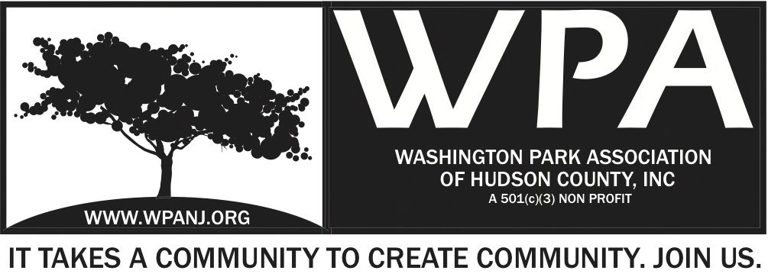

WPA General Monthly Meeting Minutes 9/8/14
Meeting start at 7:30
Mission and Code of Conduct

Roll Call:

Attendees:
Ellen Pelli
Peter Basso
Charles Stofico
Lisa Blando
Euceph Brown
Karina Medina
Debra Guidal
Wendy Paul
Katherine Crawford Gray
Quorum not present – 8/4/14 minutes not ratified.
Mory Thomas
Nick Caballero
Quorum present

-Minutes from the Aug 4th WPA General Monthly Meeting were ratified.

President and VP report – to be reviewed at Event/WP Live! Update
Treasurer’s Report will be added to minutes
Secretary – Terri not available (on travel)

Green Acres 7:35 PM
- Peter Basso: Good news: after 3 years it went out to bid, checking the jersey journal notice to bidders, Hudson county div planning, planning association of NJ and NYC. Only one contractor has picked up a copy of the plan until September 16 at 11 AM. Questions until Wednesday, September 10. Next Wednesday at the Hudson County Freeholders will be going through all the bidders. WPA Trustees should plan to have a trustee meeting after Live!. Need to plug our network that it is available. MKW fronted the money to print out 10. Fee to pick up bid is 100.00, which is common. Had one on one conversation with DiSalvo. Project is going through County protocols even though project is through non-profit. Bidders should bid on all bids but ad-alternates accepted also. Ground breaking is anticipated for the end of the year but could in theory happen 10 days after bid is awarded.

Captain Martinez 7:45
- Total 92 arrests, surpassing other precincts based on other precincts. Short on manpower
- 30 officers less than the south
- 310 moving violations
- **** Report from Captain Martinez – see handout from Captain Martinez
- NWP – National Walk Patrol working on implementing
- Homeless is City Hall problem – shrubs need to be cut, gate by Holland Street needs to be cut. Teresa to contact Brook
- Murder on Waverly was isolated; investigation is still on going
- Stabbing on Manhattan was isolated
- Webster and Griffith – mischief and questionable activities, including fireworks. Rumored to be a part of Latin Kings.
- North precinct got 8 new recruits and lost 6. Two went to motorcycles.
- Union City side of park needs to police area. Jersey City follows no mercy policy and arrests all actors
- Mory will follow up regarding Dabney and bushes

Theresa
- 671 gas station side – still hasn’t been fixed.
- New garbage company – garbage that falls, trash is left on the ground or falls out of garbage can
- Large tree in front of 237 South. PSEG cut tree into a V. Trees are being cut apart
- 658 and 656 passageway. Weeds have grown into trees. Owner has made a personal dog run; weeds are 20 feet high
- Street paving list will be sent

WP Live!
- * Fundraising going well and match LAP grant, and 8K from Wendy
- Debra Goidel from St. John’s Lutheran Church spoke; will have table at Live! Pantry feeds 150 families a month. Pantry the second Saturday a month. Flyer distributed

Mary Kate Naatus, St. Peter’s University
- St. Peter’s Business class will be recruiting volunteers and will also have students from intro business class
- Mory to stop by class on Friday evening
- Freshmen through juniors undergraduate business honors class

Romano
- Walkway between NY and Palisade Avenue – by gas station. Romano said sidewalk is property owner
- Mory to follow up with Anthony regarding activities in the park regarding 3 enforcement from all responding units; Romano to look into number of hours to be assigned and will follow up with Captain Martinez
WP Live Line Up
- Cards available for distribution, share with family and friends
- Palisade Avenue will be closed for the first time for this event including a beer garden. Area will be closed off. We do not want to squander this opportunity given to us but the City of Union City. Area will be monitored and people will be given wristbands and beer will only be able to be consumed in area
- O’Connell’s run is going to go into 5th year and will be ending in event then going into line up
- Mory read through line up starting with Yoga at 10 AM
- See line up
- Norene Leddy – description of workshop planned for this year. Free clothing swap stocked with volunteers. People can come to bring things and take things. This year will feature workshop with people to customize clothes and workshop on brands Adidas and Puma – activity and times review. Workshop ends with “Trashion Show”. Theme is recycling fashion. Group/activity is “Hacking Heights Fashion”.
- Mory reviewed map and layout of event and continued line up of performers and event
- Volunteers will be in green tshirt, leads will be in orange tshirts and headsets
- Each table will have volunteers
- Volunteer training will be on September 10 and 11 at 7 PM. Two classes will have walk through and assignments. Safety to be covered at this event.

Wine Tasting Event November 14, Friday
- Will be at new Art House Production
- Ticket will be 35.00/40.00

Movies in the Park 8:55
- Program was a success; couldn’t be done with out the volunteers especially with park staff

Nomination updates, Lisa Blando 8:56
- Trusteeship and officer positions expirations read
- Anyone who is interested or to be nominated should reach out to Lisa Blando

Laura Skolar 9:02
- Big Dig update – engaging homeowners and private homes. Going out to neighborhood groups to speak to homeowners to plant front yard and or planter boxes
- Donation of 100.00 will get 250 bulbs
- Pledge form will be finalized and then sent out via Eventbrite
- Seniors can link up with younger population to plant

Milena, UC Music Project 9:08
- Introduces music to youth
- Will have a table at WP Live!

Other items 9:10
- Arts District Summit – reimbursement funds received
- HCD Development will be presenting at RNA regarding new development on Palisade Ave for apartments to include mixed use space and retail

Karina Medina, Palisade Family Success Center, Community Partnership and Volunteer Coordinator
- Will have table at Live! with clay pot activities

9pm Adjourn
Mory Thomas 2nd

