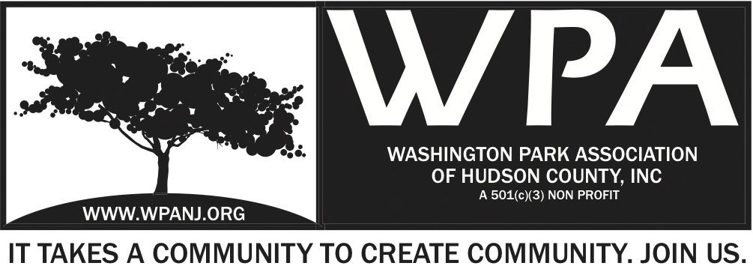

WPA General Monthly Meeting Minutes
January 6th, 2014
Start Time 7:30pm

Attendees:
Nick Caballero – President
Terri Neuner – Secretary
Wendy Paul – Vice President
David Calton – NJPD Guest
Ben Duronio – Guest
Mory Thomas - Trustee
Lisa Blando – Trustee
Peter Basso – Member
Charlie Steffer – Member

Quorum present – December meeting minutes not ratified.

7:37pm – Notice Mory Thomas/ Lisa Blando
7:40pm – Notice Peter Basso

Dave Calton
- Dec 1-28 Crime Statistics
- 44 arrests
- 1 gun summit grace
- 2 shots fired –
- 0 stabbings
- 1990 violations
- 690 parking 80 city ordinances
- Capt’s meeting 3 wed of every month
- 222 laidlaw
- NEED participation! Please attend.
- 547-5477
- If you see something 911
- Be aware of your surroundings
- Move around resources as needed. Depending on issues and call ins.
- Super Bowl – Going to bring a lot of people from other areas of the country to JC.
- Human Trafficing big issues with event. Symposium trainings for officers for issue. Super Bowl Feb 2nd.
- Call take # ID # 1st line of communication with people to the police.
- Do not always take the job seriously. Transfer to a supervisor if you are not happy with the service on the other end.
- Call takers are from the neighborhood but may not know all specific street locations.
- Issue – Bad speeding -Summit and Paterson St.
- Romano Observer Highway left.
- Issue- Central – Paterson Plank. Delayed light. Creates accidents.
- T. Romano will inquire about Human Trafficing symposium for WPA
- Anthony Romano - 595 Newark. Whether to eminent domain property. Knock down building. Jail building is disgrace. Not to code. Do not want more property to take off the tax rolls. 140 units wanting to be developed. Let Romano know how you feel about decision. They do not want to move it. Historically, this is where it should stay. Complex does not want to be broken.
Crunch
- 201-656-9989 Discount for WPA members– Crunch Gym ask for Collin

Meeting with County Parks
- Tony will get this settled regarding date/ time

Fundraising
8:20pm full discussion
- FOL – Nick will send email to wrap up FOL.
- March Fundraiser Friday the 21st.

8:20pm

Events:
- Brief discussion on preliminary talk.
- Park 3 – positive feedback - people like the new stone wall

Green Acres
- Spoke to Ken Jennings today – Heart Attack
- Phil Collins approved plans to finalize docs to go to bid
- Peter will reach out to John Duda
- Needs- Finalize Bid Specs – Finalize signage
- Mory - Scope of work. Do we have $$ to do entire project? Don’t know.
- Megan Massey – Escrow account
- Add this to agenda with the county??? Scope? $$?
- Plants selection from OUR grant. Surplus? Put into other areas of our grant.

Dave Calton – Leave 8:32pm
- Alert discolored water should be run water until clear

Other items
-Meeting with 8:30am – City Hall - Mayor Fulop Jan 16th 8:30am
-Discuss alignment – Grants w/ Dickinson, Farms in the City, City to support another FIC type of event, Visioning session, RAD, Discuss Arts district, not to turn into Brooklyn,

-Also Meeting planned with Stacy Flannigan- Health of JC citizens.

-Dept of Public Works – Repaving requests are being taken – Submit requests through Council Presidents office.

-
Meeting Adjourn 8:50
50/50 Ticket Number 393421 – Award $16 – Wendy Paul Winner – Donated to WPA.
Thank you Wendy!

