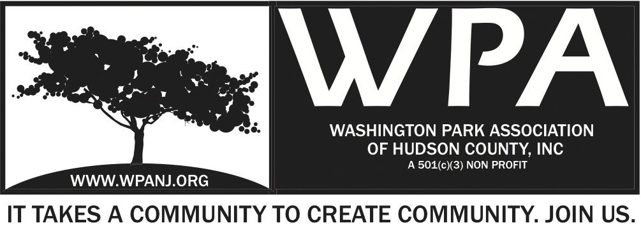

WPA General Monthly Meeting Minutes 10.3.16
Start Time – 7:30pm

Attendees
Walter Rodriguez - T
Bob Boudreau - T
Terri Neuner
Federico Nealon
Mory Thomas? - T
Wendy Paul? – T – 7:35PM
Lisa Blando? – T 7:56pm – Bob Boudreau 1st – 2nd Jay McVey
Jay McVey – T 7:35 PM
Nick Caballero
George Fujioko
Lorraine D
John Hanussak
Officer Melissa Sarmiento
Treasures Report – Separate Doc
Pres - Vice President Report N/A

Secretary Report
Focus on Nomination Committee – New Board elections next month

JCPD Statistics-
4 arrests
3505 –
1 shooting Accident
5 people in the vehicle

Laguna Lounge – Letting different people in. No problems recently.
The owner is trying to change the clientele

Oasis – often glass bottles outside

Stolen U- haul
Theft at stores always happens
Email Melissa – msarmiento @njjcps.org
22 Sherman – 44 Sherman
Friday the 14th – Volunteer

Lorraine – new member – 2 years
Need more garbage bins in the neighborhood.
Heights for clean streets

Green Acres Update
Behind schedule regarding contract
Pro Bono service is looking
Booked apt Pre construction meeting Oct 17th 10am – discuss plan and timeline

Heights Housing Forum
Affordable Housing – Key Issue with heights
Bring out – How do we make renting and owning a home more affordable?
What kind of policies can we put in place to ensure housing in the future?
Facilitate a good debate – Grass roots movement – City to provide more
Need help with marketing
Professionals needed

Forum for BOE
Mo and Brian to Moderated
Monday Oct 24th
7pm-9pm
Hope Center
RNA
Pershing Field
Western
10 candidates and 3 spots
Write a question on a card or submit through facebook

John Hunusak arrive 8:04pm
- Lorraine – More Trash Cans needed in the streets
- Owners responsible for property to curb
- City responsible
- Central Ave and Summit Ave needs more trash cans – very few on Central
- Solar powered trashcans don’t work
- Trash along streets is often because trash is put out too early
- Bobby Dee’s -Beacon / Baldwin Dumping ashes into the catch basin
- Bodega on corner- Weeds throwing down catch basin
- Keep reporting issues – Residents need to continue to call in
- Things will get better –
- What’s cities rule on idling vehicles – (city vehicle) – Diesel trucks - Report See Click Fix. – Parks and forestry
- Basketball Court Riverview Park - Someone took a piece of the fence off.

Fox and Crow Dinner
November 2
Plan – Needs to be in place
- This time next week have all details in place

Summer Maintenance Event - Plans
Friday October 14th 9am-3pm
Set up at 8
Students to arrive at 9:30am
High Tech HS – 56 students
JCPD – Sponsor
$2200 sponsorship
Bulbs have been purchased
Final Clean up
Opportunity for Community to come together – Positive
Help with registration
Send Nick an email if you are available
Fruit juice in morning
Lunch 1-2
Trio of music – via Andrea
# of Officers to attend
Team Leaders needed – Officers and Students
Inventory Storage? T shirts?

Senior Health and Wellness Update
Capacity – meeting to determine space and capacity
June 3rd
Health and Human services
Freeholders
Next steps
2 public senior
Senior Prom King Queen
Video booth – Tell a story – Some history
Connect with JC admin and UC – Heads up of what we are doing
When seniors are involved, the politicians will JOIN!

Next Meeting
October 17th Monday 7pm
Terri Neuner’s house

Nomination Committee
Elections – November Meeting
New Trustees needed
Open positions
Please tell Terri or Lisa if you plan to re run

Mory
City of Trees
JCPD
Tree canopy in JC is 17%
Should be 40%
Creating a Tree Commission
Plant as many trees as possible – Initiate
CITY OF TREES – Movie powerful
True story about tree program in Wash DC
Park and People – Group
Powerful movie – Focus on people
Friday Oct 7th
150 Pacific Ave 6-9pm Event Film screening
In conjuction with Golden Door Film
300 Artists
Free event
Drinks

Adjourn 9:05pm Terri Neuner 2nd Mory Thomas

