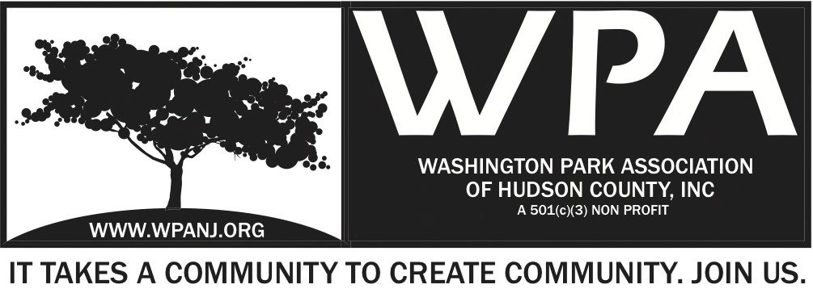

WPA General Monthly Meeting Minutes
Nov 3, 2014

- Meeting start time 7:32pm
- Call to order - Terri Neuner
- Roll call - Quorum Present
- Minutes from WPA General Monthly Meetings on September 8th, October 6th and amended minutes from February 10th have been ratified.

Attendees
Terri Neuner - Secretary
Nick Caballero - President
Ben Duronio - Trustee
Wendy Paul – Vice President
Mory Thomas – Trustee
Erin Kumpf - Trustee
Anthony Romano – Member
Vilma Cabrera – Trustee
Katherine Crawford- Gray – Treasurer
Lianna Grey - Trustee
Susan Newman - Guest
Keith May - Member
David Calton – JCPD
Kern Weissman - G
Jay McVey – Trustee
Lisa Blando – Trustee
Ryan Dowd- Guest
Beverly Brown - Advisor

President’s Report

- I have assisted with collections of Sponsorship commitments from WPLive2014.
- Special thanks to Trustee Vilma Cabrera who has create hand written thank you cards to go out to our WPLive2014 Sponsors, partners and vendors.
- I receive a call from Hudson County Director Michelle Richardson regarding a possible Farmer's Market in Washington Park.

- I was in communication with Assemblyman Raj Mukherji, Assemblyman Carmelo Garcia and Mayor Stack regarding the need for a 24 hours NJTransit bus line that runs through the Heights and supports not only Jersey City but Union City and Weehawken. A meeting has been schedule by Assemblyman Garcia with NJTransit to discuss options. I have reach out to our partners at the RNA who have been deeply involved as well. They will attend the meeting as well.
- I reached out to the NJ Charities Division to request a Letter of Compliance which states the WPA is in good standing and up to date with all compliance. We have received this letter and our Secretary Terri Neuner will upload it to our public files on our Website.
- I reached out to Mayor Stack to request a letter of Support regarding a test pilot for a Resident Only Parking which we have been requesting since December of 2010. I have been in communication with the Leadership of RNA whom have add their positive comments toward the pilot program.
- I met with other members of the Riverview Arts Disctrict community and JC Lead Planner to discus Palisade Ave. Meetings will be set for the larger community to attend.

Vice President’s Report

Treasurer’s Report
See attachment

Secretary’s Report
- Main Focus on Nominations Committee
- Interviewing various candidates over last 2 ½ weeks.
- Follow up meetings with the President
- Visit us on WPANJ.org
- Sign up as a member – Friends $20, Stewards$30, Evergreen $50
- Like us on Facebook, Instagram, Twitter

JCPD North District - Crime Stats - Dave Calton
- Intro North District – Policing Liaison
- Sept 21 Oct 18th
- 74 arrests - Mostly from crime suppression unit
- 0 shootings / shots fired
- 444 Summons moving violations – running stop signs, red lights, not adhering to traffic signs.
- 7 Juvi Curfew Summons
- 1106 total Summons
- No major incidents for Cabbage Halloween Mischief night
- Motorcycle squad - Checking on parks
- Industrial accident downtown
- Holiday safety tips. Be vigilant – Darker earlier
- 671 Palisade- requested
- 129 Franklin St. People urinating next to Stop and Shop

Parking Pilot Program - Nick/ Mory
- Resident side of the street parking idea.- Began when ball field was installed
- Cars double parked
- Run from permitted of park – Palisade to Cambridge to South St
- Brought this to Mayor Stack, He will provide of letter of Support. City Council President
- Next Step – Will send a report to RNA President Kern
- We want to get word out to RNA and provide full information
- Parking Enforcement officers will fall under Public Safety

Anthony Romano - Memorandum
- 201-795-6000 Denardo Batista for resolution

Kern - Update on Lightrail traffic,
- Discussion with NJ Transit
- Implemented improvements to signaling in Q3
- Adding timing and certain controls. This happened and corrected
- Something changed in the last 2 -3 weeks
- Snap picture and post if problem
- Manually processing light controls.
- Elevator closes 1am – 5am

Ben - Uber issue in Hudson County?
- Yes- Hudson county taxi’s fighting Uber

Arts District Zoning
- Had 2 steering committee meetings, in partnership with RNA to address new R2 zoning.
- Survey to be held on Palisade Ave. on the 15th of Nov.
- Another steering committee meeting in December.
- 2 or 3 Community Meetings on topic in Jan/ Feb 2015.

Diamond Tech Properties
- Not present
- Restaurant to be built corner Central Ave and Paterson Plank Road

Fund Raising - Katherine
- Sitting fees to be collected
- St. Peters University to assist with partnership program
- FoundationsSearch.com option
- How to contact foundations
- Conference call with Board and the organization – Educational
- Date is December for St Peters University to present to the WPA trustees

Beverly
- Recommend membership to the Foundation Library
- Many resources that we can reference for assistance.

Frogs are Green – Susan Newman

- Bring awareness - frog and amphibians population around the world are on the decline.
- Program Since 2009
- Get children and adults to get involved.
- Art contest in the fall - hundreds of kids from around the world – only 3 from the USA.
- Arts education seems to be shrinking on schools.
- Art contest is currently in place
- Would like JC to lead the way with this contest
- Meeting with BOA/ Ann Marley
- Art is coming in from around the world.
- Frogsaregreen.org.
- Dates of submission – deadline Dec 16th Ages 3-16
- Sustainable Jersey City Program – Just inducted

Planning Meeting
- Fall and Winter months after WP Live start planning for next year
- Fund raising packages/ Event planning
- Meeting to be scheduled in next 30 days

Nominating Committee – Lisa Blando/ Terri Neuner
- Susanna Latorre / William Fox assisting in interviews
- Excellent pool of candidates
- Pleasure to meet with them and excited to add to the team

Green Acres Grant- Peter Basso
- Some New developments
- Overview of Grant
- Bids came in VERY high
- A lot of pieces to the RFP request
- Scale back the requests and focus on having ONE piece done well
- Idea to focus on picnic area
- Discussion with Phil Collins
- May have more $ as other grants not being
- New York Ave – Was paid for out of a different pool of funds
- Permaculture learning garden – Tom McCann advised $25K available
- Another $25k for Picnic tables
- All together $150K available
- Pater Basso advised that funds were confirmed by Tom McCann
- Lowest bid received was $575K
- With our current budget + $150K could come close to lowest bid (base) provided.

Arts District Summit
- Reviewed by Mory Thomas earlier

Big Dig - Mory
- 90,000 daffodil bulbs – only 5k left in the warehouse
- Still searching for organizations to donate $100 and get 250 bulbs. Schools, businesses…
- 1500 bulbs at Street fair downtown
- WPA to give $100??

Nominations – Lisa/ Terri
- Irene Borngraeber not able to attend to today’s meeting. We will vote for Irene at a later date.

- On Nov 2, 2014 Katherine Crawford Gray advised of resignation from Treasurer and Trustee position. She will remain a volunteer for the organization and maintain the financial accounts for WPA as well as take lead responsibility for seeking grants.

Vote
Following Executives and Trustees unanimously voted in:

Nick Caballero – President – Term to expire 10/2016
Ben Duronio – Treasurer – Term to expire 10/2015
Terri Neuner – Secretary – Term to expire 10/2016
Ben Duronio – Trustee – Term to expire 10/1016
Liana Grey – Trustee – Term to expire 10/1016
Erin Kumpf – Trustee – Term to expire 10/1016
Jay McVey – Trustee – Term to expire 10/1016
Wendy Paul – Trustee – Term to expire 10/1016
Priscilla Renta – Trustee – Term to expire 10/1016
Mory Thomas – Trustee – Term to expire 10/1016

9pm - Motion to Adjourn Mory Thomas, 2nd Wendy Paul

