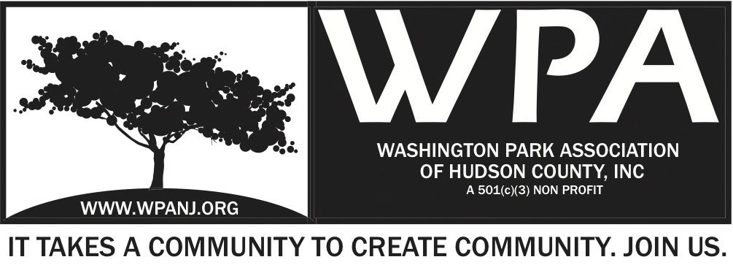

WPA General Monthly Meeting Minutes
December 1, 2014
7:32pm Call to order.

Attendees:
Terri Neuner
Wendy Paul
Nick Caballero
Liana Grey
Vilma Cabrera
Jay McVey
Ben Duronio
Erin Kumpf
Sean Connors
Tom Tredway
Lucas Gordon

Presidents Report
- Stack Meeting this Wed – Ongoing discussion light rail, 123, 119. Postponed to make it a stronger forum. Stack disgusted with NJ Transit service.
- Michelle Richardson – Farmers Market Washington Park. We have budget, but no resources to run it.
- RNA, JCPC, WPA leadership surveyed Palisade / Paterson Plank to Ravine. City does not have resources to do itself.

VP Report –
- Followed up on receivables from WP Live
- Attended WPA Trustee meeting on November 19

Treasurer’s Report:
- See separate doc.

Secretary’s Report
- Visit us on WPANJ.org
- Sign up as a member – Friends $20, Stewards$30, Evergreen $50
- Like us on Facebook, Instagram, Twitter

Quality of Life Issues
451 Central Ave – Hole
Dog droppings brought up.
Big vans parked on the Central and Poplar blocking view to turn corner
Cars parking and blocking sidewalks – Need green space at corner
Central and Paterson left turn issue. County controlled intersection.
Bikes on sidewalk on Central Ave. Many times delivery guys.

Artist District – Irene Borngreaber
Need to formalize the organization
Open Bank account
Need website up and coming
How to get around the heights
How are we funding? Not sure yet.
When is the next meeting? Not determined yet.
Reminder - JC Fridays this Friday. 53 Congress.
Please attend!
Reminder - Reservoir Xmas Party – Dec 16th – Lincoln Inn.
Grace Church

Curb Cuts - Nick- Removed this topic from the agenda.

Parking Pilot Program
Capt. Martinez is in support of it
We would like to wait.

Wendy Recognize: Trustee Irene Borngreaber – 7:44pm
2nd Terri Neuner
Nick Recognize Trustee: Erin Kumpf – 7:48pm
2nd Terri Neuner

Green Acres Grant
Plant a large Spruce – Tree lighting ceremony for the future.
Homeless, contraband
All waters have been shut off.

Motion to Adjourn 8:15pm
Terri Neuner
2nd – Wendy Paul

