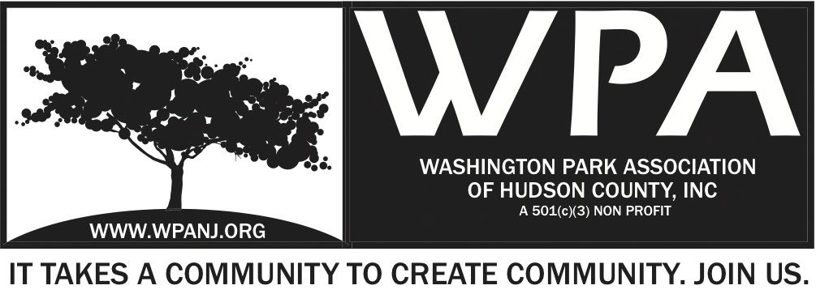
December 5, 2016
7:30pm Start

Andrea Brachfeld
George Fujioka
Erin Kumpf
Jay McVey
Terri Neuner
Wendy Paul
Mory Thomas
Charles stofko
Jennifer Lambert
Rosemary Villalta
Nick Caballero
Federico Nealon
Pat Stamato
John L
Nick Lawrence
Brianna Lawrence
Capt Martinez
Ron Ferguson
Smanatha Perez
Nick Buffum
Becky Hoffman
Joe Horwitz
Adam Reyes
Katerin Claros
Adrianna Figuerea
Lynne Mullins
Andy Lucea

Minutes Ratifies - WPA General Monthly meeting on November 7, 2017

President’s Report
Welcome all to the first WPA
annual holiday meet and greet meeting and gathering
Thank you to the officers, trustees, sponsors, community officials, volunteers, members, and everyone else who has given selflessly to this amazing organization- the WPA. We are looking forward to working with all of you this year to make this a successful, productive and most of all fun year!

I've been busy acclimating myself to the role of presidency of WPA. I've met with Terri, Nick Mory and Bob. I'd like to thank all of you for your time and expertise.
Terri has been my super supportive right hand dame and I'd like to thank her especially for her time and support.
I've been observing and gathering information on the current programs which have been in place and brainstorming new programs with Terri and Nick, which fit the criteria and general feel of community cohesiveness of the WPA.
- Trustee meeting December 12- bylaws and fundraising package
- Ongoing programs- planting in the park, garden maintenance
- Proposed programs- three mini festival musical and community events- tasting tables, arts and crafts, local businesses, face painting- change of location- gazebo- parking proximity and central location- bachata band, jazz band, rock
- Three dinners- Mardi Gras, Cinco de Mayo, Day of the Dead
- Works at home- art and photography
- Senior health and wellness day
- Proposed meetings of community groups- February to support each other- not duplicate efforts
- Proposed programs- yoga in the park- sattva yoga.
- Sunday morning meditation in the park warm weather. Cold weather too maybe
- The journey- monthly series celebrating elders of the community possibly videotaping
- Set up a time to organize the storage space notating inventory and providing a sign out sheet when people use the contents.
- Community clean up collaborating with Moriah Kinberg
Again, thank you everyone for your support and time and I'm looking forward to a great year ahead.
Secretary’s report

Met with New President Andrea Nov 16 to review and plan this meeting. Initial discussion on WPA events to plan for 2017 – Also

Trustees - take note of our first 2017 Board meeting to take place Dec 12th. – If you have not yet done so, please RSVP – It is out first meeting of the year – Everyone’s attendance is appreciated and highly recommended.

Beginning Balance

Total deposits were $1,631.91
Current Balance $19,500.18 – Last year at this time we had 17,928.94

Which included the following

$500 donation from the Fox and Crow generated Thur the Day of the Dead Mexican Fundraising dinner

$500 - Sponsorship from Jersey City Heath and Human Services for the Fall Students, Community and Law Enforcement

$250 - Sponsorship from Police Superior Officers Association for the Fall Students, Community and Law Enforcement

$109.97 Donation from Ideas for Living for the Fall Students, Community and Law Enforcement

$21.94 Reimbursement from Ideas for living from a vendor for the Fall Students, Community and Law Enforcement

I would just add you and Andrea are working on adjusting the rate at the CubeSmart facility to a better rate.

JCPD - Statics
16 guns recovered
796 Moving violations
1520 Violations
Shootings
NY Ave Shooting – 2 guys over a girl FB Drug dealers
Separate from shootings on Webster
Mayor was able to get this – Isolated incident
Police Officer # has risen? Additional officers redeployed
Quincy St? Can’t speak about it- Claiming - Home Invasion – Drugs?
Story – Mory – New community members astonished that police help and speak to

Nick C provided updates on Green Acres Grant and final park plans

Various neighborhood holiday events announced

Riverview Jam.org Jam session
Next Tuesday 13th Holiday Party! Full catered dinner from Patsy’s
AMAZON WISH LIST TOY DRIVE
Saturday Toy Give away on 1pm-4pm at your oofice
Mayor is holding annual concert 12/17 Fulop 6:25 Pm Loews
Visioning Leonard Gordon Park
Pershing Field Gar ding Fund raiser Dec 14th Fante and Hudson City Rats
8pm James Ruggio Poetry Jam in FC

Adjourn 8:00pm

