WPA General Monthly Meeting Minutes 4.1.13

Meeting Called by: Terri Neuner
Facilitator: Nick Caballero
Time Keeper: Terri Neuner
Type of Meeting: WPA General Monthly Meeting
Minute Taker: Terri Neuner

Attendees:
Nick Caballero - President
Mory Thomas- Trustee
Lisa Blando- Trustee
Wendy Paul – Vice President
Terri Neuner- Secretary
Katherine Crawford- Gray – Treasurer
Peter Basso – Advisor
Ellen Pelli - Guest
Marcus Pelli - Guest
Sgt. B Davis - Guest
P O Del Los Santos- Guest
Bob Boudreau- Member
Dave Calton - Guest
Theresa Haywood – Guest Mayors Action
Sean Connors

President’s reports –

- 3/6 – Met with Beth Rutler regarding Movies in the Park Series in HC Parks
- 3/18 – Met with Mory, Peter, Ken Jennings and Randy Vonier regarding Green Acres Grant Plans; topics Lighting, picnic tables, placement, grill pedestals, pathways, water lines, conduit, unclassified escalation, infrastructure and building schedule. Action item was to set a meeting with Union City/Mayor Stack to mirror both aesthetics
- WPA Leadership helps plan and organize the 3/21.13 –Heights Mayoral Candidate Forum that was a great success of 300 people attended. Videos can be seen on our Facebook page
- 3/28 – Peter and I Met with Michelle Richardson, Ken Jennings and Randy Vonier of Hudson County and Mark Albiez and Ralph Tango of Union City to go over WPA Plans and UC plans. The meeting was a success and plans are in motion to mirror aesthetics
- 3/29 – Met with Terri Neuner, Mory Thomas, Leeron Tagger, Beverly Brown and Lisa Blando to plan WPA Annual Fundraiser and Annual Planting in the park event
- 4/1 – Peter and I met with Randy Vonier, Ken Jennings and John Duda regarding Green Acres Grant update and budget

Response to email regarding Homeless and Missing person found deceased on the Cliffs.

Good evening sir my name is Capt. Schifano we had met previously at one of the monthly meetings. I am sorry but due to manpower and scheduling we will be unable to send someone to tonight's meeting. I did speak with the sheriff and he said he would be sending a representative to your next meeting. You did ask 2 questions in reference to the homeless and a deceased person on the cliffs. I can say as for the deceased man on the cliffs that matter is being handled between the Union City PD and the Prosecutor Office as far as I am aware. As for the homeless situation I will try and have an answer for you by the next meeting as of now I have nothing solid that I can tell you. Again I apologize for the late email this was my first opportunity to respond to you. Have a good evening sir.

Secretary report -
Trustee Meetings held on 2/10 and 2/17
Items Discussed
- Goldman Sacks Community Team works program
- Planting in the Park
- Garden and Maintenance Program
- Movies in the Park
- Fundraising ideas
- Candidate Forums
- Plans for the Picnic area

Treasurers Report

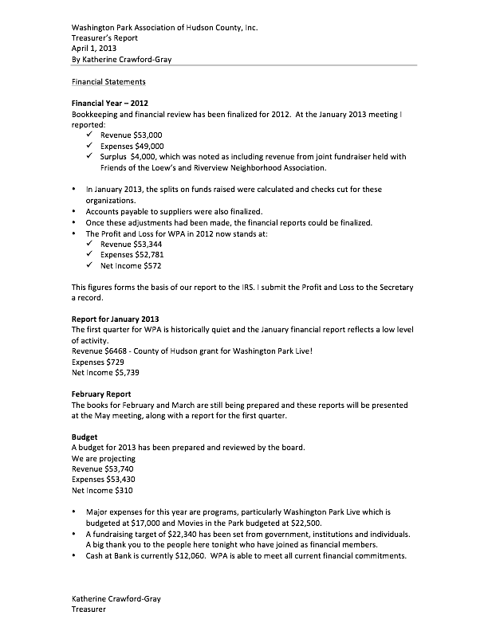

Officer Dave Calton –
New officers Shifts 12-8

Stats
-Burglary Auto 1 in area
-Residential break ins 4 in area
-12 robberies – shoplifting – congress st March 28th
-CCTV units
-Arrests for burglary
-Park Closes at 10.
-14 year old Kids in park after are in violation curfew.
-New speed detection devices coming soon. Kennedy Blvd
-Summit Ave by Pershing Field
-1 Carjacking – Baldwin Ave
-Shootings this month – None reported
-Gun recovered from automobile arrest
-Graffiti meeting postponed.
Mory- Can WPA/ RNA help to initiate meeting? Yes..
Peter – Do schools get involved in help with Graffiti? Yes
Ellen – Laguna Lounge – Fights every weekend. Squad car there at closing.
201-547-5477

Teresa Haywood-
Graffiti locations –
275 up from 200
194 Manhattan Ave
192 Manhattan Ave
3286 JFK Blvd garage facing beach St
White/ Red van parked on Beech st 3495 Kennedy Blvd – License Plate XS1350
615 Palisade Ave – Apt building
Corner of North and Palisade
621 Palisade – Replaced telephone polls – Shaved at bottom?

Katherine - Pop up electronics stores- OK as long as sidewalk is not blocked
They can sell every weekend

Green Acres Grant updates–
Peter Basso
- Discussed need for proper lighting in Picnic area. No additional hazard or safety issues.
- Electrical conduits.
- Days away from bid
- Plans are in full detail. Good schematics. Landscape
- Changes –
  - AVA ramp on Palisade and 2nd street will be removed and will add ADA to other side.
  - Skateboard
  - Union City has more funds for Park 3 along NY Ave. Soccer field to be tidied up. Still passive space, benches and landscaping.
- Streetscapes will be made.
- Will UC repave picnic area adjacent to NY Ave?
- Natural crossings on UC and NY
- Ralph Tango will share all plans and specs
- One change to our recommendations – Alternate to scalloped fencing. Rail fence suggested like in NYC parks.
- Budget- Grant $372,000. $300,000 for construction with $45,000 for contingency. $27,000 engineering costs.
- $330,000 to play with.
- Open space funds are part of total funding.

Minutes - Feb 4th meeting minutes need to have attendees added and are approved.

Events Committee
- Motion to cancel Planting in the Park discussion
- Nick – First event- Continue with the community
- Peter – We owe in to the community to maintain the beds. Leave it to tidy. Maybe not a full blown ambitious planting.
- Wendy – When would we have it April 27th.
- Idea to have the GS day next to the planting. May 30th and 31st.
- Have 1 volunteer day prior to clean up planting.
- Send communication that planting in the park is moving.

Motion to vote on the date for planting
- WPA Live – 5K run – Meeting w/ Maria Bradley - O’Connell Run.
- Sharing PR dollars

Fundraising
- Update – Date - Hoboken Vine and Hudson Vine to donate.
- Silent Auction items needed.

Additional Candidate Forums –
Thursday 18th April

Parking Petition – Good question for Candidate Forum.
Peter Basso –
- JC Park Coalition
- Pershing Field Spring into action day – Seed bombs
  - Community vote to move the playground to the basketball and tennis court area. 1-4 pm this Sunday
Brian Pass – Introduction.

Adjourned 9:06pm Mory Thomas - Second

