WPA General Monthly Meeting Minutes
Monday April 7, 2014
Quorum Present
Begin 7:31PM Call to order

Attendees
Robert Luckritz – G
Mory Thomas – Trustee
Wendy Paul – Trustee/ VP
Terri Neuner – Trustee/ Secretary
Katie Sheehan- Lopez - G
Ron Clement – G
Phil Cohen – G
Andrew LaBruno – JCPC North – G
Captain Edgar Martinez – JCPD North – G
Nick Caballero – President
Bob Boudreau- Trustee
Peter Basso – Advisor
Suzanna LaTorre – M
Vilma Cabrera – Trustee
Kern Weisman – G
Euceph Brown – G
Doug Fleiohe - M

Presidents Report
- Have coordinated Movies in the Park details with the assitance of Katherine, Mory, Vilma and the board.
- Worked with Mory, Ken Jennings regarding details of planting in the park 2014
- Asked Mayor Stack to provide 3 trees and 4 shrubs for the planting
- Worked with the board, RNA and other organizers of the Riverview Arts District Visioning and raised funds for the visioning as well
- Met with JCPD Captain Martinez of the North District regarding graffiti issues

Vice President’s Report
- Introduce Rob Luckritz, JCMC presentation
* Will speak about sponsorship during Fundraiser agenda item

Treasurer’s Report
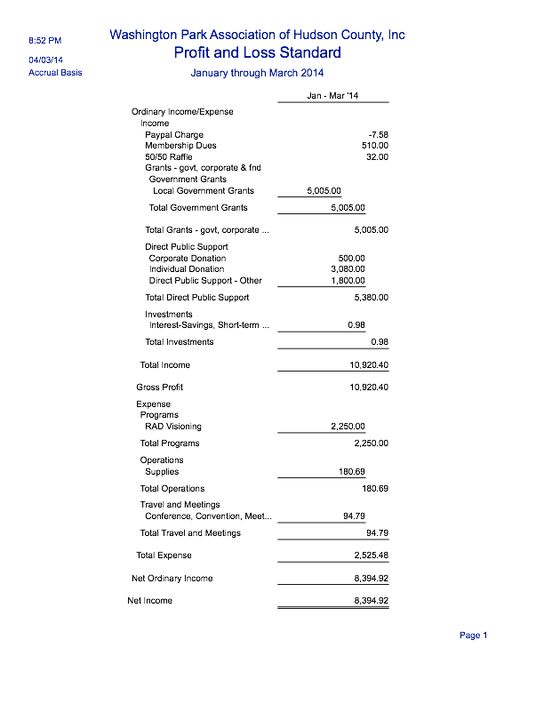

Secretary’s Report
-Please visit our website www.wpanj.org - Friends 20, Stewards 30, Evergreens 50
-50/50 – or simply donate
-Volunteer opportunities – Come weed with us!

Phil Cohen – Candidate - Freeholder June 3rd

Police Statistics – Capt. Martinez
- Arrest 66 - 1 gun/ 3 for year
- 808 moving Violations
- 93 city ordinances +

- 1340 summonses
- 1162 Summit – 2 arrests numerous drug transactions
- Pit Bull shot – Used as weapon
- Waverly – 13 Ravine - 28 grams of coke w/ gun
- 4lb Marajuana recovered
- 1 week 3 search warrents
- Dickinson HS Issues – multiple arrests for drugs and weapons
- Increased patrols in park – ordinance after 10pm $2500 to parents for kids in the park

- Graffiti – task force centralized
- Community service idea for offenders
- 214 Hopkins – arrests of taggers
- Charging kids on all $$ to fix it
- Send photos to:
- Policenorth@njccps.org
- Loews and Home, hardware stores…given one week to comply with paint selling or arrested.
- Turn around time for building owners to remove tags?
- Homeowner/ business owner needs remove 30 days..then summons
- -Peter Basso – How are tagged location prioritized to clean. – Older 1st.
- Community groups should volunteer
- Gang symbols? Not an issue
- 7 people in the last month arrested from different towns, Passaic, Clifton

DOT
If you see something out of control with traffic regarding Pulaski / 139 closure
Jitney question

Nick Caballero - Pulaski/ 139 Closures
- Michael Yun – Working to get meeting Mayor Stack
- Public meeting held – Study for buses in the heights to increase capacity
- Overnight service increase on 119 Bus
Kern
- Assessment of bus service
- Difference levels to work through to increase– Academy- NJ Transit –

Wendy
Light rail traffic must be improved. On the days malfunctioning, can we get a police to direct traffic.

Mory - Be sure to POST POST POST on social network – The city is watching the social media sites.
Head of light rail operations will be
Tricello – Chief of Lightrail.

JFK- to Tonnelle - Newark Ave
Viaduct - first week June to open
Ravine/ New York – End April to open

County Items – Anthony Romano
- County potholes are being filled up.
- Prisoners to be cleaning on Paterson Plank
- Running for Re election

Jersey City Medical Center
- 2 bankrupties since 2006
- Have received subsidies
- 2008 brought in new CEO – Mr Scott
- Focused on core mission
- Positive prfit in last 100 years
- HIV
- Homeless clinic
- Neo Natal Intensive care
- We wouldn’t take our pet to JCMC
- Worst to first!!!
- Barnabas Health System
- Walk in clinics
- 33% of Hudson county people go to NYC for help
- EMS provider – crown jewel of JCMC
- Major drain of hospital .
- EMS – World class EMS
- Only accredited EMS in Hudson County.
- Some of lowest response time – 9 min response time to 6 minutes
- Intelligent predicablity of emergency calls to EMS program
- At the end of the day- it changes lives.
- Implemented and resussitations increased 50%
- Recurrences of issues will trigger alert to health departments
- JCMC is not for profit
- $28M
- $40M Charity care received
- -NJ State law states that ANY hospital can assist and
- -49% of patience are not insured or under insured
- -Walk in clinics – No insurance but nominal charge = to general co pay $25-$30
- -Service concierge at JCMC – Help getting appts made, blood work,

Lisa Blando – Notice 7:40 pm 2nd Mory Thomas

Katie Shehan
Journal Square CSA
- Farm shares June – Oct = 22 Week
- 7 different
- now ½ - $286 - $13/ Week
- $462 – Vegetable for season
- $13 fruit per week
- Pick up in Journal Square – Hudson Pride – Every Monday 5-8 pm
- Trip the farm

Fundraising
- Liberty Savings Fund is voting on Wed
- Corp sponsorship package has been created
- Support! If your company matches

Events
- Planting in the Park April 26 – 9am-2pm
- 500 plants to be planted
- Union City to provide lunch

Goldman Sachs community team work
- In TriPark
- 20 Employees
- $2300 provided by GS for
- April 22

MITP
- Michelle Richardson to vote Thursday with county
- Animated movies

Green Acres
- Grant $375,000 + found monies
- Improving features of Washington Park
- Upgrades – signage- Picnic area
- Bid Specs are basically complete
- Increase height of signage
- Ken Jennings – John Duda Meeting today. Finalizing the bid
- Full speed ahead

Arts District Summit – Visioning!!
- Fun day
- Entertainment
- Orange and Olive food
- Contracted outside facilitator
- Over 125 RSVP – Maxed out space
- Waiting list in place
- Goal is to co create what we want the district to be!!
- Protect without prohibiting
- Copious notes will be taken

Sustainable JC

- We did not win grant
- New opportunity to bring idea to Charter School

Basso
- Budget Season @ City Hall
- Wed 16th 6pm Meeting to discuss

Philip Cohen – Membership Evergreen - Full Dues Paid

Trustee Vote – To approve WPA 2014 budget discussed and reviewed at 3/22 Special Trustee Meeting - ** Approved ** Unanimous **

Doric
- Trees on north part of Park 4 – Need to have cut, replace fence
- Stack has promised to paint bridge
- Who is responsible? Doric or City?
- Wall on Paterson Plank

50/50 - $55 take in
Winner - Nick Caballero – Donated $27.50 to WPA

Adjourn 9:20pm Terri Neuner 2nd

