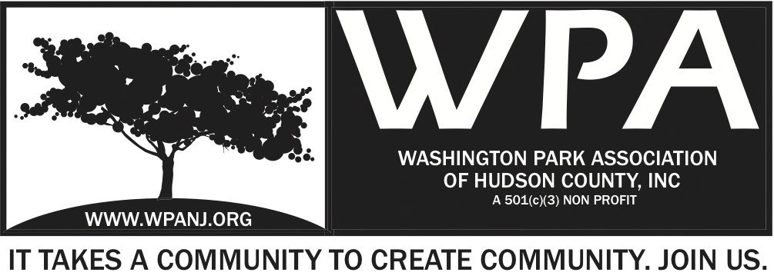

WPA General Monthly Meeting Minutes May 2, 2013

Attendees:
Terri Neuner
Anthony Collet
Federico Nealon
Nick Caballero
Euceph Brown
Walter Rodriguez
Oneida Rodriguez
Erin Kumpf
Tony Romano
Mory Thomas
Peter Basso

President’s Report

- Attended City Coucil meeting to petition for a nation search for the new city planner
- Attended meeting wthi United for Clean Streets, Director of DPW, Mark Redfield and Joseph C. Roselle, Vice President of Regional Industries
- Met with Art and Sarah of the Fox and Crow to plan June 8 WPA dinner
- Participated in Keep JC Beautiful street cleaning event
- Met with trustees to plan a music event in the park for jazz fest week.

Treasurer’s Report

Bank account balance as of date: $22,940
2016 Expenses for the past 2months: - $3,328
Mainly: Insurance fee for - $818
Tree purchase for GS - $1,300
Momentum expenses - $678
2016 Income for the past 2months: $1,146
Mainly: Momentum income +$1006

To we are in deficit $2,360 of for those 2 months.
The tree purchase will partly be covered by GS event once the funds are transferred.

For the Goldman Sachs event, the budget is $2,300
The estimated expenses will go above the budget:
Trees $2,000
Truck rental: $200
Tools + food = $400
Additional workforce from Nick's Caballero's team = $ 300 ?

Each event should better be budgeted as previously mentioned and supported with adequate Fundraising package (Committee leaders: Wendy and Jay + any extra help).

Secretary Report
April 10th Attended the Heights Civic Engagement Forum
Well attended.- Lots of Municipal people
Explaining their rolls / Jobs
Gist – Where do you go to get things done – Graffiti, pot holes, Great QA
RRC 1st - POC for most items. Follow up with the specific department.

April 16th – Rendezvous to Pick up plants for GS
May 1 - Tree farm in Bethlehem NJ for others

April 23rd – Keep JC Beautiful Clean up – 10 People North St-Hague/ Central to JFK

Today – Spoke to Joe Cecchini to confirm our events.

Minutes for today’s Meeting – We voted on 4/27 on “Spring Clean up in honor of DJ Wise – Unanimous except for one Nay vote. We will discuss this later.

JCPD Report – 3/20/16-4/16/16
Officer – JCPD Richie Lopez

Total Adult Arrests – 48
Guns Recovered – 1
Total guns recovered 2016 – 5
Shootings/ Shots fired – 0/1
Stabbings – 2
Moving Violations – 641
Curfew Violations – 0
City Ordinance – 47
Total Summones - 1258

Recognize Erin 7:44pm Bob Boudreau 2nd Terri Neuner

Requested last years statics – YOY improvement?
12 more officers graduating
Bicycle units out with the better weather!

Lopez - President of the Pony League – Pershing Field
Organized Team to run the park
160 kids playing for free
Free uniforms – Bags, bats. Growing and moving in the right direction

Works at Home Series
Jenny Brover- Photographer June 17th
2/3 of cards should be printed – 2000 ordered last time – 1000 should be sufficient
All artists have been contacted
WIDE ANGLE
Funding needed to print collateral
20% to WPA if anything is sold
$100 Clean up service
$20 suggested donation
Cheese – Wine – Central Ave Liquors possibly- Cheese Shop
Working with Artists to provide all art.
8:01pm Mory Thomas Recognize Bob Boudreau – 2nd Terri Neuner
Musician – Pianist – Bayonne – Has his own keyboard
*Walter to send site with Painist site.
$200 – Cost for musician

Senior Health Day
Mission Statement – to be sent
Participation at different levels
Healthcare providers
$1000 - $100 levels
Cemetery Plot - Where to go, who to go to??
**Walter will send outline of the program**
What we would like it to be – How much money backwards that we would like to raise.

Music in the Park Series
Mory speaking with Bryan B.
Invoice to come
Need a stage – RNA has one, city has one as well
Food Trucks? – Who can call?
Rain Date? We need to figure
* 2nd Thursday
Where should we hold this?
$6000
Carepoint $5K - Used for all programming but focus on Music in Park
*

IT Communication
Teasers
Created forms for Momentum / Wide Angle

Goldman Sachs Update
3 trees so far
Inventory of bunker boxes – Wednesday
Walked park with Nick
20 signed up + 5 WPA
Tortas from Aldis + Vegetarian sandwiches
Rain or shine
New gloves to be purchased

Building / Zoning/ Community
City – Live Work spaces – Powerhouse district. Not used – City Selling and $$ should go back to live work or affordable housing.
NJ Community capital –
Bob Spoke at council meeting.
Nick C – Attended meeting w/ CASID – Developer wants to put in Municipal parking Heights - ot by Burger King – 5 stories with community center. 7 total floors proposed – 2 levels of office or school and 4 -5 levels of parking.
Lot for workers on Tonelle

A Spring Cleaning – DJ May 21st – Nick Caballero

Event - Vote approved by board
Board Vote completed April 27
9 Aye/ 1 Nay

4 volunteer Teams
7am sign up table
Volunteers 8-9 for check in
9am -1pm Clean up Earth wods – Weed, mulch, soil
Goal to have all gardens in park 1 all completed , spruced and mulched
Lunch 1-2 Food TBD
2:30pm Plant tree and dedicate
Sound system – DJ’s wife and family can say a word.
Hawthorne Tree -
$500 Cork Screw + Total $2K Donated
After Party at Bob’s house

Green Acres – Peter Basso
Bids were rejected last week by certified mail
Vendors incorrectly completed forms – Added written notes
Problems with following directions
Going to bid 3rd time on May 12th
Minimal period of time – If no one bids, then go with negotiation with individual contractor.
Dan Salvo – HC says negotiation is a last resort – This IS a last resport
With next go around, nothing should be changed but new dates

Dinner at FC
2nd Wednesday – June 8th
Sliders – Black Bean burger
$500 donation – percentage
Brown Paper Ticket
$40 – Dinner and 2 drinks
$60- Dinner +
Maybe $25 – Flat fee – $500
Promise 25 people confirmed
Burgers/ Sliders – Engage the community - Test new menu items
Service is lacking – need to focus on service and timing

Adjourn – 9:10pm Adjourn Terri Neuner – Bob Boudreau 2nd

