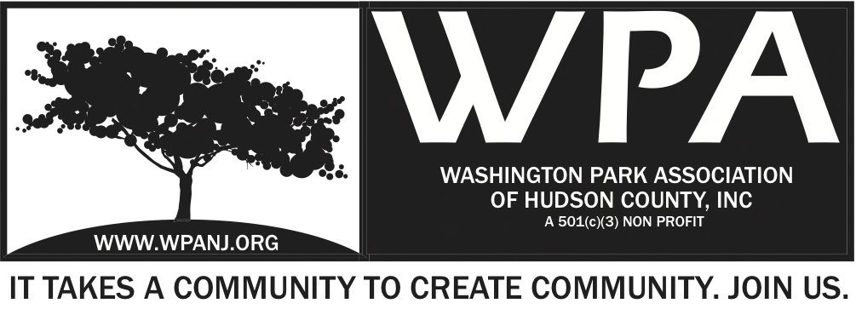
Monday, May 5, 2014
WPA GENERAL MONTHLY MEETING MINUTES

Meeting Location:
St. John's Evangelical Lutheran Church
155 North St.
Jersey City, NJ 07307

Attendees:
Nick Caballero- T
Marcus Pelli- M
Tania McCormick
Andrew LeBruno of the JCPD North District- G
Wendy Paul- T
Peter Basso- Advisor
Theresa Haywood- G
D. Fleisher- M
Euceph Brown- M
Katherine Crawford-Gray- T
Bob Boudrea- T
Vilma Cabrera- T

7:30 PM: Call to order
Minutes for 3.3.14 were ratified in the last meeting, not the minutes for 3.3.13.
Minutes from WPA General Monthly Meetings on 2/3/14 and on 4/7/14 were posted on website and are ratified.
Minutes from special trustee meeting were posted on WPA’s website.

Officer Reports:

President’s Report

- Continued working with the County Parks Division regarding the
Movies in the Park 2014 Series
- Worked with the Riverview Art's District planning/organizing
committee to plan and execute a very positive effort for our future
here in the Heights.
- Worked with Ken Jennings and Mory to secure the right plant
Selection for our 2014 6th Annual PITP Program held on 4.26.2014
- Special thanks to our Trustees and Administrative Volunteers (Terri Neuner, Lisa Blando, Katherine Crawford-Gray, Wendy Paul, Vilma Cabrera, Mory Thomas, Doug and Lois Korvis) for coming out and adding to the success of the day.
- Coordinated 3 20-foot trees and 4 shrubs for the PITP program donated by Mayor/Senator Stack
- Made a Sponsorship Ask from Empire Realty who generously said yes and cosponsored the planting in the park program as they have for the last 4 years
- Coordinated groups from Great Futures Charter School, The Boys and Girls Club of Hudson County and Union City High School's Horticulture Club
- Last I have been helping to coordinate a successful Goldman Sach TeamWorks Planting event schedule for this Friday the 9th from 9 AM to 3:30 PM

Vice President’s Report
- Wendy: Attended the Riverview Arts District Visioning Summit. 104 of the 108 registered showed up. It started at 9 and ended at 6 PM. A lot of planning went into it.
- On the 25th we coordinated the planting for PITP and the PITP went well. It was a very godo April.

Treasurer’s Report
- Katherine Crawford-Gray:
Report for January-April 2014
• Historically, the first quarter for WPA is quiet with our LAP grant from the County of Hudson being the largest revenue source in January.
• However in 2014, WPA has agreed to be the fiscal sponsor for the April Riverview Arts District Visioning Event, which has boosted our revenue by $5,000.
• In addition, we were approved as a vendor to deliver the Movies in the Parks event for Hudson County – 12 movies in 6 parks over July and August. This contract includes wages for a event manager and additional staff on the nights of the movies
As at April 30, 2014:
Revenue: $62,716
Expenses: $12,085
Net Income: $50,632
- Fundraising
- In order to meet our projected revenue for the year, WPA still needs to raise $17,000 for events in 2014, which is a third of our fundraising. The majority of these funds are for Washington Park Live! Arts & Music
- Major expenses for this year are programs, which are over 80% of expenses
- A big thank you to the people here tonight who have joined as financial members.
- WPA is able to meet all current financial commitments.

- Budget that was approved on 5.4.14 will be posted on the website.

- Need to raise $17k this year, mainly for WP LIVE. Our programs are over 80% of our spending.

Secretary’s Report
No report because Terri is not present.

Police/City/Crime Report by P.O. Andrew LeBruno:

- 5 guns recovered in April. A total of 8 guns in 2014.
- Have a team that works in the evenings and a lot of the arrests are coming from there.
- One stabbing: a family member stabbing his grandfather and he died. Said his grandfather was stealing all his gfs. He was arrested.
- 398 moving violations
- 5 curfew violation
- 515 city ordinances
- A big ticket writers is currently out due to an injury so are down in ticket-writing at this time. He’s very proactive but out.
- 20 juvenile arrests.
- Are doing pretty good. Crime suppression units are active and productive.
- This is a big marijuana area.
- Last night (5/4/14) had a midnight tour of people breaking into vehicles.
- Plaint clothes officers have been doing a great job. DOT has been pulling officers.
------------
Audience Comments/Reports:
- 184-186 Webster Ave.: lots of car maintenance on street, a lot of in and out, things being handed through passenger windows. Multiple calls have been made but they all just disappear as soon as a person calls. Seems they are getting tipped off or have a connection to the police force. Begins after 3 PM and continues into night. Heavier in evening and in summer, but it happens all day sporadically in the morning and throughout day.
- 508-510 Palisade: there seems to be a drug dealer around there
- Runs from Summit to Light Rail to sell expired Light Rail tickets. He waits outside and at times he tries to sell coke to customers of Corkscrew. Has a mohawk.
- On Leonard there is a truck that pulls up and sells fruit and does it at WP too. Puts the fruit out and sells it. Commerce will deal with that. Probably doesn’t have a permit.

Graffiti Update

- Graffiti will get busier in the summer.
- 7 grafitti artists were arrested from Clifton/Paterson.

Audience concerns for Theresa Haywood:
- 671 Palisade: rats are around the property
- 63 Congress: is abandoned property. It is constantly dirty. It isn’t boarded up.
- 2 big potholes between Bowers and South on Webster, near the cleaners. Close to the South Street Cleaners and south 3 blocks.
- Theresa: If you have an issue with a property you must send email with the exact address.

Department of Transportation Update/ Pulaski Skyway/ RT 139 Road closure

- 139- We’re looking at mid-June
- Nick talked to Michael Yun, Councilman Raj, and Mayor/Senator Stack about needing better and more frequent transportation in the morning and ending rush hour, along with overnight transportation. Need to be able to get in and out of the city.
- 119 bus started to run more frequently after transportation talks and buses are now cross-honoring transfers from bus to bus
- The 9th and Congress Light Rail doesn’t go to the Hoboken Light Rail Station over the weekend. Only goes to Newport Mall.
- Romano suggests talking to Councilman Garcia about this.
- There is a limited number of officers who check tickets. There seem to be way too few.

- Last month the sewer system of the corner house at 671 Palisade. It gets clogged and backed up into Ellen’s house. Gets sewer water into her house. Need to be back on a regular schedule (twice a year) doing maintenance on the sewer there.
- Each house has to separate their own sewer line.
- Maybe this can be maintained quarterly

- 8:08 PM: Fundraising Updates

- Liberty Savings Fundraising Sponsorship for MITP 2014
- KCG: Freeholders approved having WPA delivering the MITP
- Liberty Savings agreed to be the sponsor. Wendy was successful in soliciting $6,000. County is also fundraising. WPA has commissioned additional work from an expert institutional fundraiser who works for the Liberty Science Center.
- Prepared template letters and corporate sponsorship packages to solicit funds from new sources to raise the $17k we need to raise.

Romano has worked with Michael to have potholes filled.

Events
- Planting in the Park in the Park 2014 recap
Nick: Empire Realty helped us pay for plants. Stack gave us 3 20-feet trees. We had Girls Scouths from Jersey City and Uinion City. Union City HS Horticultural Club planted a new bed. Doug was phenomela with the Girls Club. Great Futures Charter School brought many students. It was a great day.
Thank you to all those who went.

- Goldman Sachs Day Update
  - Date- Friday May 9th
We raise our own funds, but between Goldman Sachs and private businesses we have been able to plant $2,000/year in the park.

- Movies in the Park Series - Update
In July and August, we must have a trustee at each movie. We need to have help from the trustee.
We have a paid movie manager position.
Movies are Wednesdays and Fridays in July and August.
If it rains on Wed., the rain date is on Saturday.
If it rains on Friday, the rain date is on Sunday.
Movie manager will be liaison between WPA and County, oversee development of marketing, coordinate flyering, liaise with Jersey Journal for placement of ads. Must have a driver’s license and a car.

Green Acres Grant Update
- MKW - Grading and Planting Options
- Peter: Have been narrowing down the list of to-dos’ before going out to bid on project.
- Had a meeting in April with MKW and filled in where trees needed to go and finalized details, so requested an updated budget and it was over-budget.
- Yesterday, WPA trustees met and we thought of where we can get things paid by other means or cut back on expenses. $38,000 just in trees, but in Park 3, Mayor Stack promised hundreds of trees that can’t fit in that park and he might be able to pay for them to be put in other areas of Washington Park.
- Could also look at other funding opportunities.
- Parking area could be repaired but is in a good condition and has handicapped space and could last a couple more season. WPA could support the County to get funding for that.
- Peter had a conversation with Ken today. Ken clarified on other funding sources WPA is exploring.
- County identified unspent funds on a Green Acres grant. Money could be reprogrammed towards our grant since it’s a use-it-or-lose-it. The first place the money would go to is the New York Avenue streetscape. Idea is to get UC’s contractors to do the work on New York Ave and County would pay them out of the Green Acres reprogrammed money. Ken will talk to someone in UC to lock them in on that and get UC to commit on the trees to save us $38,000.
- Ken will be in touch with Peter about next steps.

Other Items

- Arts District Summit
- It was on April 12. Location: PS #8.
- Thank you to everyone who made it possible. It was very well done.
- The first of any post-committee meetings happened yesterday: the artists table that met to discuss an artist directory (what the artists do, their specialty, what services are offered). Will make a community calendar (info on shows, local artists playing anywhere even outside of Jersey City, etc). Want a legal write-up about what the arts district designation means for artists. In a couple of weeks there will be a website.
- It was a long day but people were committed.
- Some people said there was too much talking in the beginning, but we ended that to split people up into 7 groups.
- Everyone who participated was positive and we can’t expect change instantly. There are things happening that we will see over time. We need to take action.
- A survey about the RAD Summit will be sent out in the next few days.

Memo on WPA’s Joint Fundraising Protocol
- Peter re-emailed a copy of the memo on joint fundraising from pro bono counsel as well as a sample joint fundraising agreement.
- Please take a look at these closely.
- Send any questions to Peter so he can run them by the counsel before trustees vote on whether to adopt these recommendations.
- Vote will take place in general meeting in June or July.

No 50/50 Drawing

Meeting adjourned at 8:30 PM

- Agenda items that were moved to next general monthly meeting:
  - FRESH Program Opportunity
  - Great Futures Charter School

