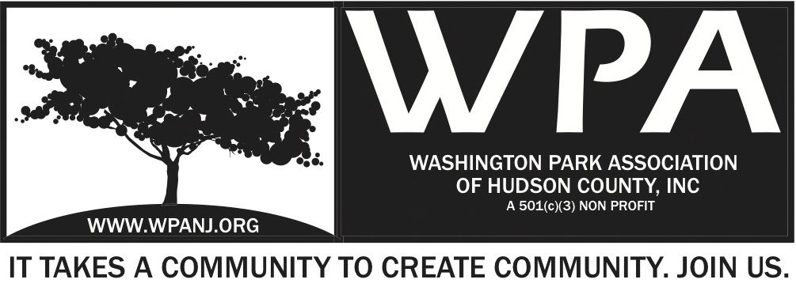

WPA General Monthly Meeting + Special Trustee Meeting Minutes
July 11, 2016
7:32pm Start

Attendees
Bob Boudreau – President
Terri Neuner – Secretary
Judy Waddleton – G
Walter Rodriguez – T
Mory Thomas – T
Federico Nealon – M
Erin Kumpf – T
Officer Lopez – G
Jay McVey – Vice President

Quorum present

Minutes from WPA General Monthly Meetings and Special Trustee Meeting on March 31st, April 4th, May 2nd were uploaded to the WPA website. Are there any changes or omissions needing to be addressed? If “No” the minutes will be approved. - ***Ratified

President’s Report
Items to be detailed in meeting notes

VP Report – Not present

Treasurer’s Report
Opening balance $20,781.79
Closing balance $22,059.12
Main transactions for June 2016
Goldman sachs +2,300
Works at home +1,526.61
AIG 2015 Donation match +1,000
ABTees T-shirts -530
RJO Music event -1,500
Print square -419 I need the receipt from Printsquare please and need to know the split between event s
Storage -245
works at home -840.90 (cleaning services + 2 artists cashed their checks)
Works at home summary:
Estimated net result of +140.91
I need the receipts from Walter / Bob
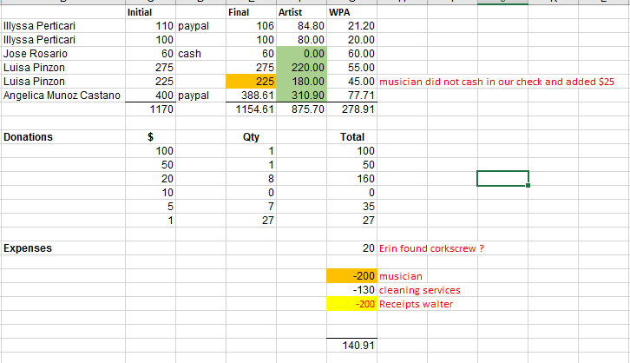

Still have not received the Carepoint $5,000.
Other outstanding receipts not received:
P. Basso Greenacres Journal pubiclation ; 5/12/16 -540.95
Dunkin Donuts for volunteers : 5/24/2016 -104.71
Printsquare: 6/10/2016 -419

Secretary Report
Maintenance in the Park - Making great progress
Tue/ Thu 6:30pm -8:30pm – Meet by dog run
Saturday – 10am-12pm Meet in Tri-park
Working with Karen DeFazio regarding 2016 permits for upcoming music events

JCPD – Monthly Statistics
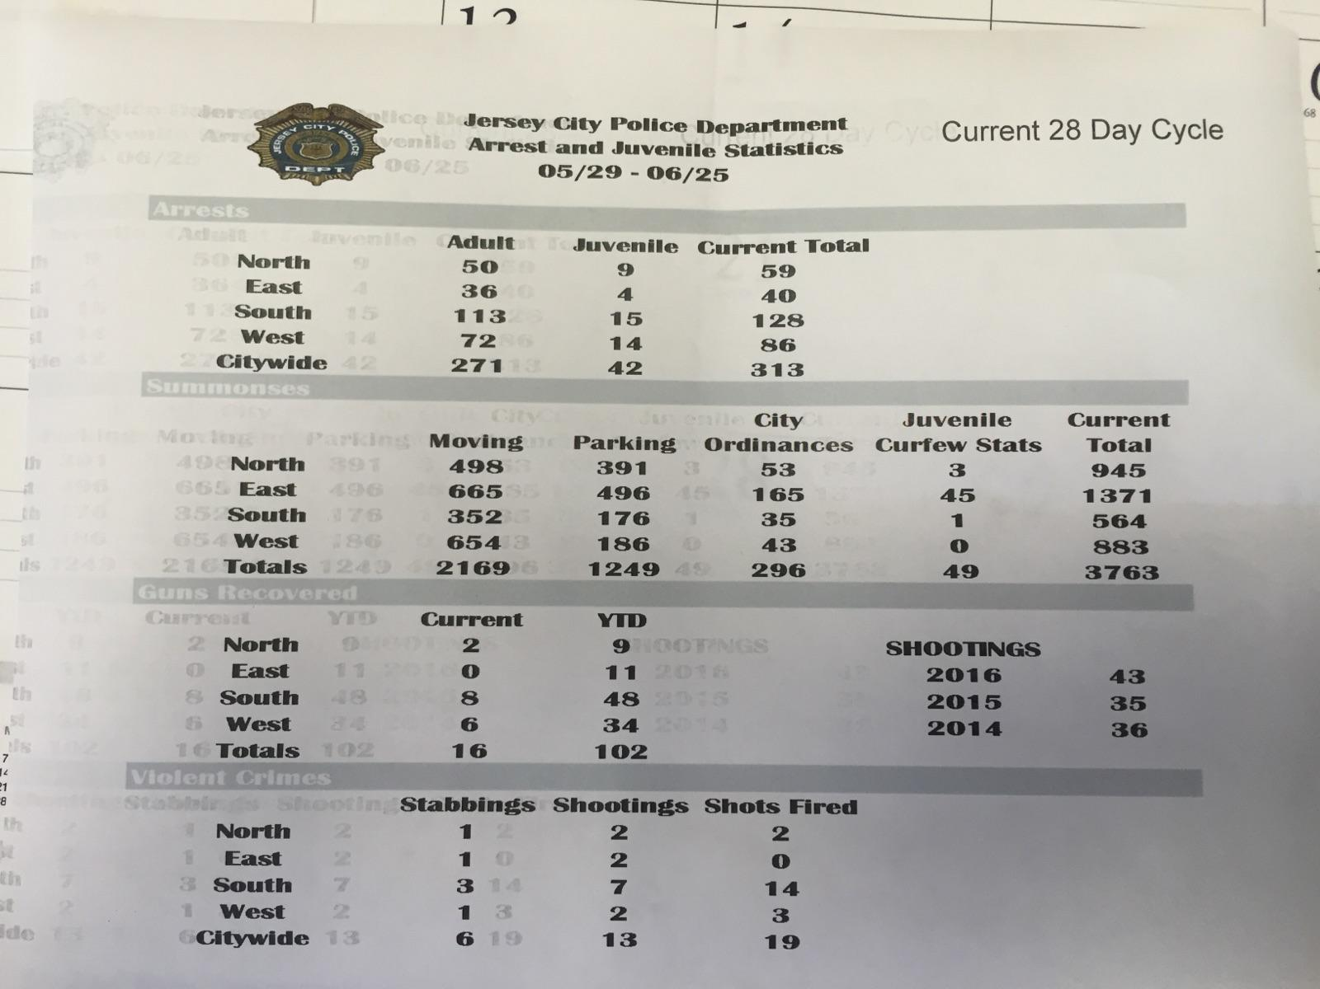

Judy Waddleton
St Anne’s Festival
- Going out the community to get help!
- Trouble in the past with manning the booths
- A few Volunteer hours
- Arch Diesis code of Ethics must be signed
- Applications to fill out will be left with WPA for assistance
- Food Served– Sausage Peppers, pizza, ….
- Need help with Wheels – 18 years old – Gambling involved
- Sand art, face painting
- 50/50 raffle

Green Acres Grant – Mory
- Letter to go out to previous bidders
- Then negotiations
- Possible changes to the original plan
- County is very much behind us to get this completed.

Summer Maintenance Program

- 3 Days per week
- Need volunteers!
- Tue Thur 6:30-8:30 Dog Run – Sat 10-noon Tripark

Adjourn – 7:51pm

Trustee Meeting - Begin 7:52 pm
Fundraising
- Need to come up with a cover letter
- Allow sponsors to pick what they want to sponsor
- Phone call out – Email follow up to each potential sponsor
- Reach out to politicians soon – Next year – election year!

-Senior Health Day - Proposed September 8th
-Move to next year/ Spring time
-Legal Aid would be great to add to line up
-Motion to vote to move the Senior Health Day to Spring 2017
2nd Terri Neuner
We will vote that the August WPA General Meeting

** Action ** Event Committee to hold meetings to review -
Senior Health Day Planning Meetings
Beginning Aug 22nd
Sept 12th and Sept 26th
At Bobby B’s
7pm

Sponsorship Package
Change heading from WPA Live – Summer Music Series To
-Art and Music Programming

-Add separate section for Senior Health 2017

Notice Jay McVey -8:30pm
2nd Bob Boudreau

Sponsorship letter Template letter to be written.
**Action**Mory will provide old letter and we will tweak.

LAPP Grant - We have received it for the past 6 years.
Application due on October 1st
We have templates of written in the past
Note- ADA access plan needed in any programming
*Separate meeting needed to review LAPP application.

**Reviewed Sponsor List – Assigned calls
Action*** - August 1st Calls to be made to potential sponsors
Prepare invoice to send

Summer Music Series
Need to better Promote
Generators – Both – Gas?
*Jay to reach Margo for gas can.
Tables
Banners
Tablecloths
*Erin to reach out to Food Trucks.
*Rain Date – Wednesday July 20th
9am – Rain date to be determined.
Two People to make the decision of the rain
Thursday Erin and Bob to make call

Half time – Bob will speak

ACTIONS
- Changing dates to Aug 10 and Sept 7
- ***Advise the county.
- *** Reprint Cards – Erin

Works at Home – Wide Angle - Recap

Attendance was low
Those that attended donated
Discussed others who could curate
(Megan McKee)
Blunda to host?
Need a better way to handle credit cards
Need someone to work the door!
Need Photographer
People liked the photography
Artists were happy
Santiago Cohen – Potential host

Adjourn 9:45pm
2nd Bob Boudreau

