Meeting Agenda – WPA General Monthly Meeting Minutes

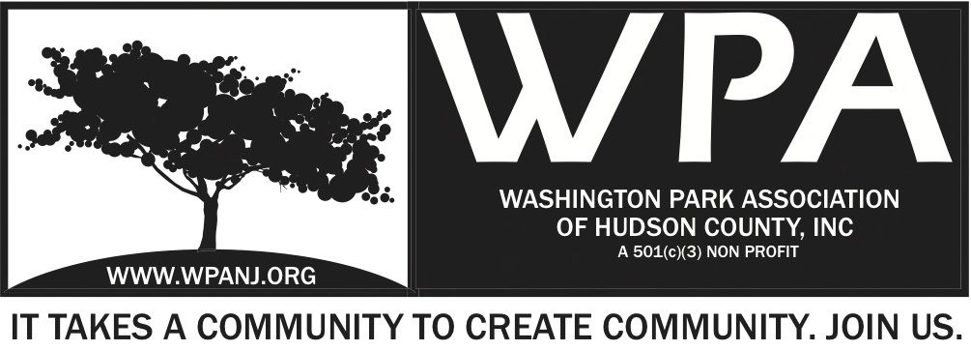

WPA General Monthly Meeting Minutes
Aug 4, 2014
7:30pm Start

Recognize Lisa Blando/ Vilma Cabrera 7:41PM
Peter Basso 8:13pm

Attendees:
Wendy Paul - VP
Vilma Cabrera - T
Bob Boudreau - T
Lisa Blando - T
Peter Basso - Advisor
Mory Thomas – T
Terri Neuner – Secretary
Alizaida Hernandez – G
Laura Escobar – G
Euceph Brown – M
Johanna Riera – G
Avery Church – G

Quorum present
Minutes ratified - 6.2.14 and 7.7.14 Meetings

Presidents Report
- Worked with Cat and county regarding movies in the park series.
- worked with WPlive events committee to plan program, fundraiser and logistics.
- signed voucher doc and delivered it to the county parks division for second mitp payment.
- paid visit to parks division to sign green acres plans for submission to bid.
- met with Mayor Stack to ask about support for WPlive.

Vice President’s Report
-Assisted Movies in the Park series series began with a rain date. Attended Kearny movie with the Millers from Liberty Savings Federal Credit Union
-Reached out to several potential sponsors for Live! sponsorship

-Attended weekly WP Live! event planning meeting. Event details and timeline to be discussed later in agenda
-Attended Hudson County Chamber of Commerce Non-Profit meeting to bring other non profits together (7/23)

Treasurers Report
N/A

Secretary Report
-Weekly Event Committee Meetings Every Monday
-Met with Guttenburg Arts Aug 2
-Met with O’Connell Run Aug 2
-Like our Facebook Page
-Movies in the Park
-Memberships – Friends $20/ Stewards $30 / Evergreens $50
-50/50

Union City Horticulture Club
Discussed their roll in the club
20 Members in total group
They will research issues with plants in the garden
Advisor Ms. Smith
Back to school Sept 4th.
Talk to Ms. Smith Advisor for additional partnering

Discussion on Big Dig –
Taking the bulbs to the front yard! Friendly competition!

8:07PM
Fundraising updates
Inserra $1000

Leads per Mory
-Walgreens interested in sponsoring
-Coco Bakery

-Vilma created Google Doc to load funding spreadsheet.
-Please add info as you receive checks
-i.e TD Bank asked Mory for W-9

-Lisa to contact Assembly Men
-Changing date on Sponsorship Package to Aug 14th.

MITP
-Cat is doing a great job
-May need better outreach for volunteers
-Good feedback on forms –
-Rain days have to be called by 3pm
-Issue in Bayonne with screen set up .

Events Committee
-Honors Business Class from St Peters University
-15 students
-Need to donate community hours
-Need to come up with 5 ideas for them to help us.
-Mary Kate Manages them – We just need to provide ideas
Start in Aug 22nd

Ideas
-WPA Live- Timeline for next year – Post mortem
-Future Funding – Boiler Plates for Grants
-Annual Membership – Membership Drive
-Next Years Lap Grant
-Succession Planning
-Recruitment Package
-Format of Meetings
-Website
-Green Acres Grant

Fundraiser
-Wine tasting – Central Ave- November big event not happening, but they still want to have it. With WPA?
-November 14th Friday 7-9pm
-Tickets $20-$30
-Minimum people 200 to attend
-Need permit Apprx. $200
-Need Wine glasses $200
-Food Snacks $600
-Venue needed
-Table Cloths $240
-Marketing Budget
-CAL would market
-Buckets – Spit
-12 Tables
-Moderately priced wine would be best
-Discuss option with Central Ave Liquors vs having Bob B work on wine tasting fund raiser

Green Acres
-Waiting to go out to bid
-County Engineer – Questioned all plans
-County - Does not understand issues from 3 years ago. OK
-County has Public Works -Freeholders – Ken wants to give them one more update. to be safe Aug 12th. We do not need to be there.
-Out to bid immediately after as long as approved.
-Final Final bid specs were done and in final signing phase. This copy is then duplicated for all bidders.
-We are responsible for marketing- Lists to send to.
-Open Space Special is providing us a list.
-MKW will help.
-All information has to go into the newspaper and webites
-Bid out for 10 days.
-When bids come back, special trustee meeting will be needed.
-Ultimately we will make the final choice.
-Bid will be for ENTIRE project.
-Add Alternate if details are not possible

-Additional discussion

Art Summit
-Mory sent everything to Robin
-She is vacation now but will flup up with her for next steps.

WP Live Discussion
-Discussed the Guttenburg Art Group and O’Connell Run
-Green light on bands

Adjourn 9:15pm
2nd Wendy Paul

50/50 - $10 take in Euceph Brown - Winner - Ticket# 393493

