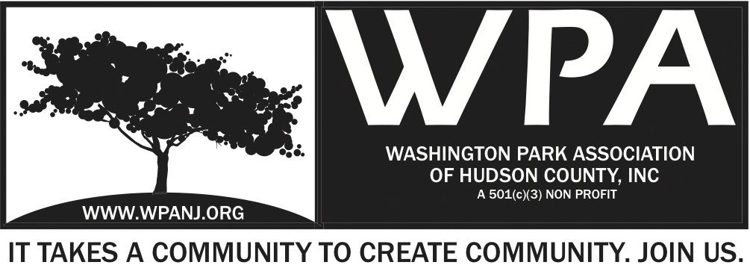

WPA General Monthly Meeting Minutes 2.6.17

Start time – 7:32pm

Attendees:

Minutes from the WPA General Monthly meeting held on Dec 5 were uploaded to the WPA website. Are there any changes or omissions needing to be addressed? If “No” the minutes will be approved.

President’s Report
-Completed the transfer of storage space from Hoboken to Good Friends
-Went to the MLK meeting where the county agreed to fund the remaining monies due
-Had a trustee meeting where we tried to divide the sponsor list to get sponsorship, discussed Mardi Gras fundraiser
-Went to the Kresge grant meeting
-discussed the Mardi Gras fundraiser
-Held meditation sessions every Sunday at 9:30 am

Treasurer’s report
$23,235.89
$22,722.12

2 Payment for postcards – Remco Press
$195 – Self Storage

Secretary Report
Attended Kresge Meeting at the Statuary

JCPD Statistics read
-Burglaries – Riverview area Washington Park area.
-Video / Cameras let the Police know.
-Let the Police know if you have video cameras around residency to assist with surveillance.
-Bid out for new camera system throughout the city
-Coffee with the cops Feb 16th Canco Lofts.

Journal Square Neighborhood Assoc.
Canco Lofts Association
Both will be in attendance.

Andrea Brachfeld - Notice Jay McVey 8:00pm – 2nd Terri Neuner

JC Municipal Courts
Stacy Dix

Community Court is housed in Municipal Court
Community Service and Social Services.
Burglaries – Low offenders
Treatments to providers
Looking for feedback from the communities-
Community Services could be provided by WPA – Show individuals skills
Low Level offenders = No prison time – Low level drug charges, Prostitution, Loud noise, graffiti, trash.

Communitysolutions@jcnj.org

Jersey City Community Solutions
Factors Advisory Board – New Community Service opps in the area – QOL issues change.

Safe Streets JC
Paul Bellan- Heuer
Originated with Dunkin Ave Neighborhood Assoc.
Neighborhood resident was killed and organization started.
County got grant money to get County street improvements
$5.4 Mil grant $$ secured so far.
Extending to Greenville – Want to replicate it
Homicides are well publicized
59 deaths since 2010
Additional disabling injuries.
Property damage
Enforcement was the missing piece
3 deaths in 3 weeks in JC on Kennedy Blvd
Anything goes on the streets in JC
Safe Streets
Citations large numbers in JC
Traffic safety Unit initiated by Fulop
Ticket
Community Planning Meeting Feb 18th 10:30am-12:30pm
Post it on our site

Brian Heights Votes
Civic Engagement
Non -Partisan
Promoting involvement in the community
51.2% of population cast vote

Heights Votes – Brian Rans Looking for assistance
Ask your neighbors
Join Brian – Every Sunday at Riverview Farmers Market
Talk with local artists, musicians.
SIGN UP! Help!

Nick Caballero – Green Acres

Summary of the program to date
Potential Ribbon Cutting June 3rd.
Little League request - Requesting Field house to be updated for Little League
Soil irrigation – Thicker

Send pix of the Park to George

Mardi Gras
Dinner – Sponsors
Corkscrew is in $500
If we sell tickets- We need to get a liquor license
Liquor
Decisions and go forward.
Amount of people 50 Tops

Facebook Event
*Terri - EventBrite – Liquor License
50 People cost per person – Professional Kitchen
Catering – food cost a third $20 per person
*Jay will go into Lee’s and get booze donations
Set up and Clean up
Need 4 people to help set up – 5pm –
* Margo to look up artists - Piano player – New Orleans Music – Budget ?? $250 my proposed budget.
*Plates utensils – Mardo Gras Beads – Erin!
*George Website and Eventbite

Terri Neuner - Adjourn 9:01pm
2nd Andrea Brachfeld

