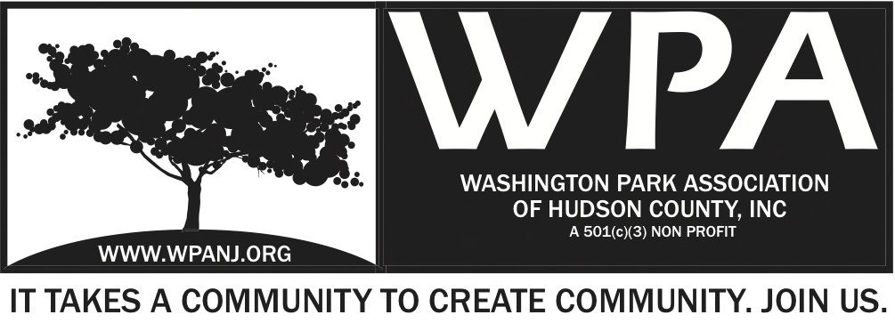

WPA Special Trustee Meeting Minutes
662 Palisade Ave
7:30pm-9pm

- Call to order 7:39pm
- Roll Call
- Introductions

Attendees
Nick Caballero
Mory Thomas
Terri Neuner
Den Duronio
Liana Grey
Erin Kumpf
Priscilla Renta
Lisa Blando
Doug Korves
Beverly Brown
Bob Boudreau
Irene Borngraeber 8:15pm
Jay McVey 7:48pm
Wendy Paul 8:04pm
Peter Basso 8:36pm

1.) 2015 Approved Events and correlating budgets
Memorandum of Understanding – We must submit our schedule of events for the following year.
See document – 2 Big Spring Programs - We apply for Goldman Sachs community Teamwork – May 8th
Week after, Planting in the Park.

Garden Club – Tea and Garden idea.
Idea for Program -Corporate Volunteer Program possible.
MITP – Background detailed by Mory. 5th year.
WP Live – Sept 19th – Need to discuss date, possibly adjust.
Big Dig – History detailed by Mory – 5th Year.
Ben - Correlating Budget – Little light on funding this year.
Both Planting and Goldman combined – approximately $2400 Goldman/ $1406 Planting
- Insurance for trustees included in policy for plantings

By Law Review
- Oct 1st – Voted on no less that 7, no more than 15
- Read Amendments– Article IV and IX– Rules of WPA – To be clear. Work and WPA should be separate. We are nonpartisan. WCE category, by law, we must be nonpartisan.
- Review Article IV – L. Absences; Vacancies read.
- Please read through all by laws
- Roberts Rules – We do not completely follow them, but they are an important guide to move forward with. As we grow, we will need to follow them and use them more and more.
- Minutes/ notes are very important.

8:30pm

WPA proposed Resident Only Parking Pilot
- Park 1 – JC only
- Park 2,3,4 Union City
- Lack of parking issue has been discussed especially during summer months during ball season. Issue has been slated until now, since new ball field.
- Idea to have resident parking 1 side of street, other side 2 hour parking.
- RNA and other orgs interested to join and help us.
- Fulop to sign letter to go to city council.
- Pilot program proposed: from Paterson Plank road to South St. / Palisade to Cambridge.
- Committee needed to assist with parking – schedule, timing, best practices, research, partnership w/ city.
- Peter Basso- Driveway Ordinance Council Pres met w/ RNA. Schedule to be with planning board Dec 2. Would be great if WPA could join.
- Planning board memo created opposing parking ordinance.
- Under law, Planning Board can do “nothing”
- City council can over rule
- Same procedure
- Ordinance - Cutting Curbs – houses w/ 16 feet between house and sidewalk to build driveway.
- We should coordinate efforts w/ RNA. Ensure we are on the same mission/ page.
- Currently you cannot cut curb. With variance, you can apply for one.
- Mory will send out a letter and information on a proper vote .

Vote for Trustee – Irene Borngraeber
- Introduction – Artist, Exec Director Liberty Humane Society, founded the Distillery.
- Vote - Unanimous!! Welcome Irene

Committee Discussion
- Think of committee you would like to be a part of. Email will be sent out by Mory.

Conflict of Interest Policy
- Has to do with anything you are associated with outside WPA.
- Please read, sign and bring it back.
WP Live
- Thank you cards have been sent out by Vilma to sponsors and contributors.

Idea - Letter head should have all trustees. Email addresses created for WPA.

* Note - Table Farmers Market discussion due to limited time.

9:02pm
House Keeping
- $120 Sitting Fee
- Robert’s Rules of Order- Hand out

Holiday Trustee Get Together
- To begin after monthly meeting. Monday Dec 1st
- Party to begin 8:15pm
- Short meeting to be held.

Peter Basso - Green Acres- Update
- Ken Jennings is no longer with Hudson County – Resigned
- Worked hard over last 2 years to build relationship
- Meeting Randy Voinier, Architect w/ Phil Collins.
- WPA has requested additional $150K for project
- Maybe have response by end of year.
- Need to work on replacement relationship for other plantings.
- Ken was familiar with our operations.

9:13pm

Note: St Peter’s presentation to board. They want to move the Tuesday 16th at 9am-11:30am.

Nick Caballero - Meeting Adjourn 9:18pm
Wendy Paul - 2nd

