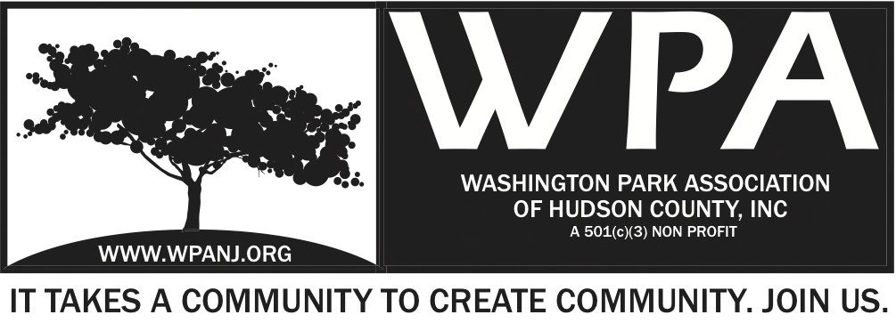

WPA Special Trustee Minutes
January 13, 2014
Start time 7:00pm

Atttendees:
Nick Caballero - President
Mory Gene Thomas - Trustee
Lisa Blando - Trustee
Wendy Paul - Vice President
Terri Neuner - Secretary
Vilma Cabrera - Trustee
Robert Boudreau – Trustee
Katherine Crawford-Gray Treasurer
Peter Basso – Member/ Advisor
Michelle Richardson – Hudson County Parks Dept.
Ken Jennings – Hudson County Parks Dept.

Discussion comments:

HC - Transition from Tom McCann was not smooth.

P Basso –
-Issue - Imposing requirements last minute
- If WPA park events needs approval, please let us know early on. Prevent last minute scramble for needed items.
-Ken/ WPA relationship great from beginning!!
-Enthusiasm with park employees is great.
-Again - ARF, if it is needed, let us know and we will do it. Please don’t let us know at the last minute.

HC - Beth from office had knee replacement..
HC - Every year, for this event, WPA will need an ARF.

HC - In the past, some things were allowed that should not have been allowed.
HC - We have set precedence with the county parks. All agreed.

Notice Lisa Blando 7:41pm Mory Thomas 2nd

-All agreed, more generic MOU for any “grant” / “program agreement”
-
-HC - Big Dig – WPA does not need MOU as this is the Parks Coalition’s responsibility.

- Memorandum of Understanding between The County of Hudson and The Washington Park Association of Hudson County, Inc. 7:50pm

Ideas:
-HC – “MOU Amplified sounds” - We should strike it.
-Strike Tom McCann and Peter Basso

7:56pm begin to review MOU document:
HC- Comment - Make it generic as possible
HC - Add “the county will submit for freeholder approval.”
HC - Submit ARF to the freeholders.

Discussion of editing document:
WPA -Combine 4 & 5
WPA -Main thing needed - Approval process for the document at the Parks Dept.

File discussion:
-WPA will keep all documents on file if needed by the county.
WPA -Discussed: Union City held Jazz concert week after WP Live. WPA would like to know of these types of events taking place in Washington Park going forward.
WPA -Events calendar should be posted on HC website
WPA -Insurance – WPA’s policy run from March to March

- WPA 2014 Community Engagement Programs and Events

Program Discussion 8:01pm

Give more details
HC County “Wants email 30 days before to provide more details”
HC -All information on requested events is needed in writing.
HC -County requests: 1 week before event – reminder from WPA to provide what is needed from the county.

MOU
#3 - Garden Club and Maintenance program
#4 - Is 3 and 4 the same thing
Page 3 – Question – “Other events” – WP Little League opening ceremonies. What does WPA do? – Nothing really. We simply go to support…
- No more lawn signs – Lawn signs disappear and get vandalized
-WPA Live event – Per Michelle, Beth would like to sit down in June with group to review the event ideas.

- Hudson County 2014 Movies in the Park Series 8:01PM – 8:30PM

8:12pm – MITP discussion

HC - What do we need?
-Dedicated person/ resource
-WPA - In the past, we had Manager, Supervisor, Coordinator
-WPA - We would like the county to help fund all the WPA events. $25,000 (in addition to the $30,000. Project management is needed.
-WPA - We would like help funding based on information that Katherine provide as MITP takes our resources away from allowing us to fund raise for our WP Live event.
-HC – Starting point to hire college kids- or staffing MITP and WPA take over a management role or Supervisory roll.
- WPA - Need resources for set up, collateral, staffing events, prep
-HC – What would it cost with staffing?
-HC – Please provide the budget for full MITP – A budget which with = information as to what was presented last year.
-
Comparison Case study
–Hoboken - Jerry Fallon
- What is the Hoboken budget?

HC Need MITP pricing proposal - Feb 3rd.

Adjourn 8:45pm - Mory Thomas - 2nd Terri Neuner

-

