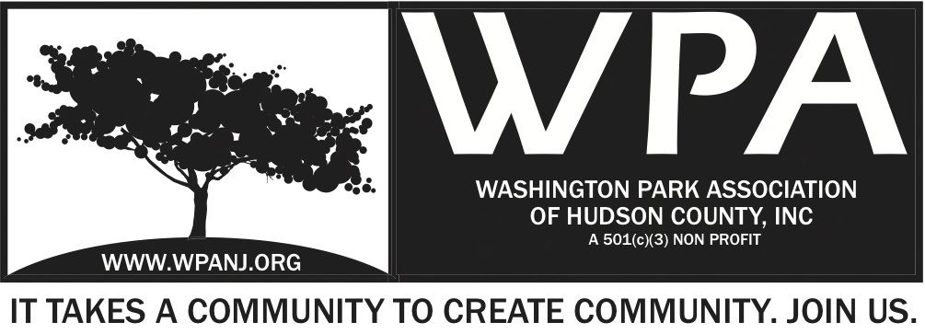

WPA Special Trustee Meeting
Sustainable Jersey - Grant
December 4, 2013

Meeting Start Time 7:30pm

Attendees:
Nick Caballero
Mory Thomas
Wendy Paul
Katherine Crawford Gray
Vilma Cabrera
Bob Boudreau
Lisa Blando
Beverly Brown

Committee Work Session for Sustainable Jersey Grant application.
Reading/ working edits made per round table discussion.

http://www.sustainablejersey.com/grants-resources/sustainable-jerseysmall-grants-program/

Main discussion items:

-Changes made to the original 9 to 9 document.
-New Project name to be created.
-Adjusting timeline to meet grant deadlines
-Removed Arts component
-Google document created to share and review for committee.

Meeting adjourn 9:15pm

