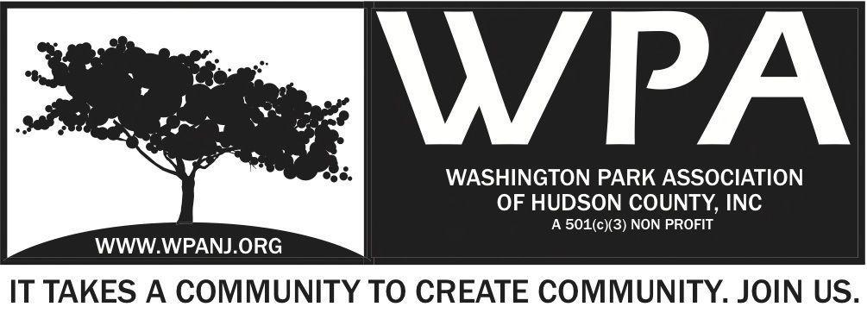
Board of Trustees
Bob Boudreau – President
Jay McVey – Vice President
Anthony Collet – Treasurer
Terri Neuner – Secretary
Lisa Blando – Trustee
Louis Fernandez – Trustee
Erin Kumpf – Trustee
Wendy Paul – Trustee
Walter Rodriguez – Trustee
Mory Thomas - Trustee

WPA Special Trustee - Meeting Agenda
September 19, 2016
7:00pm – 8:15pm
129 Franklin St #D6
Jersey City, NJ 07307
Time | Item
7:00-7:05  7:05-7:50  7:50-8:00  8:00-8:15 | Welcome and Attendance  Review of Green Acres Grant details and contract award  Motions:  1.) Motion to name Nick Caballero as Special Advisor to the WPA regarding the execution and management of the Green Acres grant to improve Washington Park and Lincoln Park  Second -  Vote - Ayes __________ Nays ____________  Trustees not present  2.) Motion add Nick Caballero and legal counsel to negotiate and finalize the contract with Sita Contruction at $808,800.00.  Mory Thomas 2nd  Construction grant the Green Acres Washington Park and Lincoln Park Improvements project to Sita Construction Co. in the amount of $808,800.00.  Second -  Vote - Ayes ____________ Nays ____________  Trustees not present  Final comments/ Adjourn

