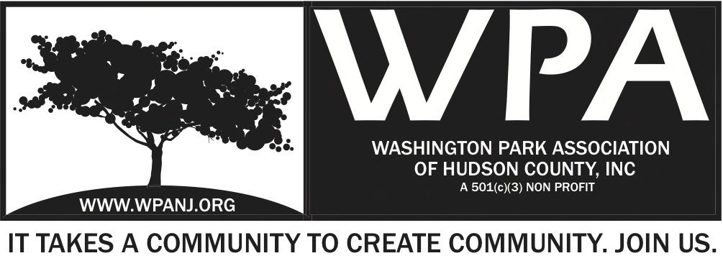
Board of Trustees
Andrea Brachfeld – President
Terri Neuner – Treasurer
Mory Thomas – Secretary
George Fujioka – Trustee
Erin Kumpf – Trustee
Wendy Paul – Trustee
Jay McVey – Trustee
Mory Thomas – Trustee
Federico Nealon - Trustee

WPA Special Trustee Meeting

Location: Gino’s – 380 Central Ave, JC, NJ 07307
January 24, 2017
Time: 7:30pm- 9:00pm
Time | Item | Owner
7:30pm  5 Mins | Welcome  - Call to order  - Roll Call | Andrea Brachfeld
7:35pm  15 Mins | Green Acres Project – Discussion and Vote  - Discuss and vote on allocating $10,000 of WPA funds to use as matching dollars to raise $30,000 to pay MKW Landscape Architects additional fees. The additional fees will cover their services through the end of the Washington Park and Lincoln Park Green Acres project.  - Yay or Nay on proposed plan | Nick C
7:50pm  10 Mins | Nick Lawrence – Trustee Vote  - Introduction  - Vote –Nick Lawrence as new WPA Trustee  - Yay or Nay - Raise of hands
8:00 pm  30 Mins | Mardi Gras Fund Raising Dinner  - Special Guests / Partners– Margo Parks  - Discuss venue/ logistics/ funds/ menu  - Tasks and timelines | All
8:30pm  20 Mins | WPA 2017 Sponsorship Packet  - Board actions / responsibilities | Open Discussion Board
8:50pm  10 Mins | Updates  - Storage Unit  - Meditation/ Yoga  - Closing Comments | Andrea
9:00pm | Adjourn

