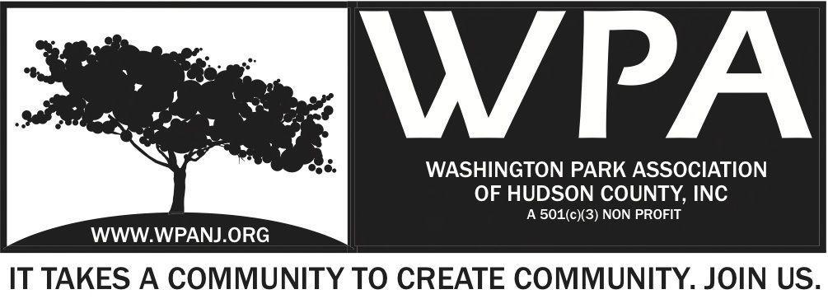
Board of Trustees
Bob Boudreau – President
Jay McVey – Vice President
Anthony Collet – Treasurer
Terri Neuner – Secretary
Lisa Blando – Trustee
Louis Fernandez – Trustee
Erin Kumpf – Trustee
Wendy Paul – Trustee
Walter Rodriguez – Trustee
Mory Thomas - Trustee

WPA Special Trustee - Meeting Agenda
August 23, 2016
7:30pm – 9:00pm
237 South St – Jersey City, NJ 07307
Time | Item
7:30-7:35  7:35-8:05  8:05-8:25  8:25-8:35  8:35-8:50  8:50-8:55  8:55-9:00 | Welcome and Attendance  Committee Updates and Collaboration  - Fundraising/ Grants  - Contact task list updates  - Potential Fund Raising options  - Music  - Other Event ideas  - Fox and Crow Dinner  - Art/ Music Events  - Works at Home  - Upcoming dates  - Hosts  - Curators  - Park Activities/ Events/ Education  - Maintenance Program – Remainder of the summer  - Farmers Market  - Nomination Committee/ Community Engagement  - November Elections  - Green Acres Update  Additional  Last Comments - Adjourn

