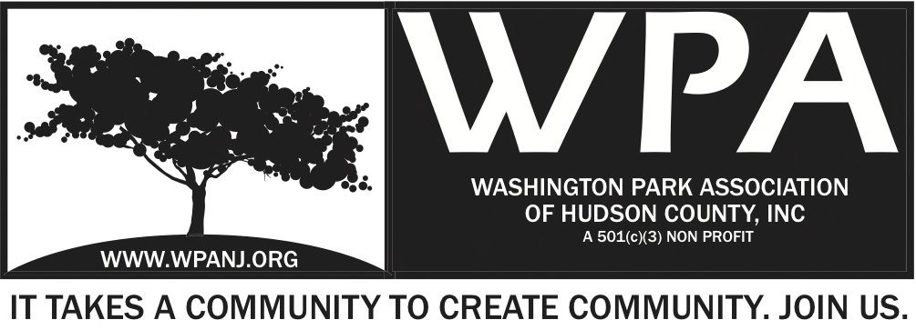

WPA Special Trustee Meeting Minutes
1.25.16
Start Time – 7:25pm

Attendees:
Lisa Blando
Bob Boudreau
Terri Neuner
Wendy Paul -
Mory Thomas
Walter Rodriguez
Doug Korves
Jay McVey
Peter Basso

Fulop Meeting Agenda discussion
Discussed 5 pre -questions that Kern created
Bob will review questions and reword them.
Key - Ask questions then state facts as back up

7:36pm Terri Neuner Recognize Lisa Blando – Doug Korves
2nd Mory Thomas

Add a questions on:

Parking
Zoning
Transportation
Crime
Taxes
Education

Question #3 – Many items consolidated into one

Bob’s Intro – To discuss snow removal
Need to incorporate western slope in questioning.
Also, Central Ave question

Committee Discussions

IT/ Communication/ Website
Mory added as Admin
Per Jay, Effective organizations - 4 times per day posts on FB.
Please filter any items to this team to post on FB and Website

Fundraising / Grants
Have not met yet.
To meet and provide feedback soon.

Art/ Music Event
Art Exhibit – March 11 – Curated show
7-10pm
Card/ Catalog created
Focus on Cinco Patas
Works at Home Series
Momentum – Would be the name of this particular event

Idea - Start of ongoing home series
Need van for transport of art
15 pieces
Per person entry – suggested donation
20% of sales - donation to WPA
Walter to display his art as well

What is the purpose?
Reasons to do an event like this:
Promote local artist
Fund raising
Community building threads
RAD involvement
Promote WPA
Drills home the need for a community Center!
$800 budget
Sponsors could be obtained
#WPAARTS
Monthly – Next proposed event June 11th

Farmers Market? No – We will not support this year.

Proposed Fundraiser event –
Performer - John Hammond
Fox and Crow - $75 – 41 people
Date based on his availability
Food included? Bronx Brewery – Donated Beer

Ideas for Park Events
Pumpkin Planting and carving
Food truck Friday/ Music
Health and Wellness Day
Bocci Ball Tournament

Scheduled:
May 13 – GS Day – Would like to bump this up a week**
Annual Planting in the Park
Specifications: Located in Washington Park No. 1, In the Learning Garden) at the intersection of Webster Ave and Paterson Plank Road. Proposed works includes (1) clean-up and preparation of existing garden beds, (2) add soil and plant a perennial plants in garden bed sites already created as a flower/plant beds in 2011, and (3) continue storm-water mitigation and soil erosion efforts along the flower bed/chain-link fence running down to Paterson Plank Rd.

Time: 8:30AM to 3:30PM

Means and Methods: Goldman Sachs employees, as well as WPA volunteers, shall collaborate to clean up existing beds, weed, edge and prepare all garden sites in Park No. 1 (in the Learning Garden and Gazebo area). We will also plant varieties of low maintenance perennial plants in existing gardens.

- Saturday, May 21, 2016 — 7th Annual Planting in the Park Program. ** Would like to bump this up 1 week**

Specifications: Location: Washington Park #1 and #4. This event will focus on maintenance of all existing beds, previously planted in 2009, 2010, 2011, 2012, 2013, 2014 and 2015: (1) the “Tri-Park” near the intersection of Central Ave. and Paterson Plank Road (2) the permaculture learning garden in the Gazebo Area and (3) the beds in Park No. 4

Means and Methods: The WPA will provide garden tools, soil, mulch, and fertilizer to prepare our existing beds for spring. We will remove any dead plant material or weeds as well as remaining winter debris. We will use soil and mulch to reconstruct swales around plantings to combat water run-off.

Other Information: This will be the seventh year for this event.

WPA Garden Club and Maintenance Program – Potential help!
Per Walter R.
Scott Kotchman – Lives in Ridgewood
Scott would help and volunteer
Crew would help but need to be paid
Potential Community workshops
Variable days
Different ideas
**Need to set date to meet with Scott to assess the park and what’s needed
This is part of the programming that NEEDS to be done.
Another teacher in JC who could assist with creating a curriculum with the kids to help – School in JC – Middle school kids

WPA 7th Annual Washington Park LIVE — Arts and Music in The Park Program. (Dates TBD).
(We are scaling back the event to smaller more frequent events throughout the year so more of the Washington Park Community may enjoy Arts and Music in a public setting.)

Specifications: TBD

Farmers Market –
Mayor Stack approached us and Marilyn Rivera – (North Bergen) –At this time, we do not have the bandwidth to support Farmers Markets as last year.
If anything, we will try to support one only in WP.

MITP- No Movies – Only option is in our park WP – Bandwidth – Part of the conversation. ** Wendy to reach out to Gerry
***Wendy to reach out Michelle Richardson – “We want to be part of the conversation but will only have in WP and we cannot fully support”**

Green Acres –
1912 Documents have been updated to
Major change since last $50K less than we thought
Match from county $300K and we thought $50K from UC
Not true
County $250K -$50K UC
If the bid ends up being $50 short, then “we should talk”
Need at least 4 weeks

Updated to contact names
Partnership Agreement – Fixed typo
Correction – Delete Paragraph 19 ??
We accept the Escrow agreement as written.
Corrected Typos

Motion to vote - Peter Basso to make best efforts to update sections 19 and 26.
All in favor - 8 Aye!

HC Chamber Of Commerce
2017 WPA membership extended
We have access to the membership portal
Chamber website is available
Cross Website - Links to be provided
Post on their FB

**Post our events on their site. Contact HCCofC
**JCPC Membership ** Application to be completed by Jay**

Building/ Zoning / Development
-52 Cambridge Meeting tonight.
Kern is speaking on our behalf.

Visioning Retreat
Re evaluate – Reassess the WPA
Going back to ground Zero

Visioning – “Foundations on Foundations”
Programmed Day
Mediator needed.

April 2nd Proposed date

Agenda for Fulop Meeting Updates
**Move up Food clothing line, add social media logo as for WPA RNA on agenda.

Adjourned – Terri Neuner 10:02pm – 2nd Lisa Blando

** Add Amazon Smile to website**

