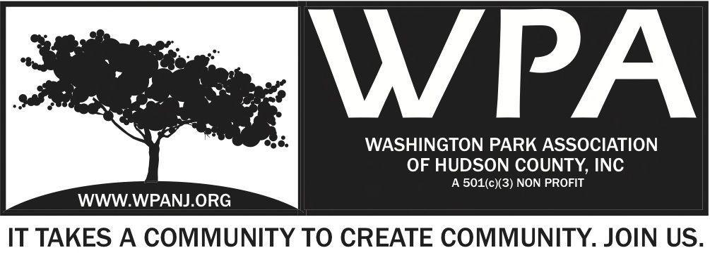
Board of Trustees
Bob Boudreau – President -
Jay McVey – Vice President
Anthony Collet – Treasurer
Terri Neuner – Secretary
Lisa Blando – Trustee
Louis Fernandez – Trustee
Erin Kumpf – Trustee
Wendy Paul – Trustee
Walter Rodriguez – Trustee
Mory Thomas - Trustee

Start 7:48pm
August 23, 2016
WPA Special Trustee Meeting
237 South St.
Jersey City NJ

Attendees
Terri Neuner
Bob Boudreau
Jay McVey - 8:00pm
Erin Kumpf – 8:05pm
Lisa Blando – 7:59pm
Wendy Paul – 7:54pm
Walter Rodriguez

Sponsors – All should be contacted by September 12th – Next WPA Meeting
Have a form – To donate.
*Erin to reach out to Anthony regarding invoice for Shuja

Fund Raiser/ Sponsor Event discussed
Grand Finale Summer Maintenance Event.
Squirreling our nuts away for 2017
** Motion to Vote to hold event **

Needed - 1 page sponsorship packet
“Prepping the gardens for 2017”
Join us as we close out our gardens.
Mid - October 15th
To coincide with JCPC Tree event?

Andrea – Help with Band info – Maybe 2 bands/ Jazz

Discuss with Nick **
Planting bulbs – Clean up
Music – Food Truck
Food Truck – Meal Ticket –
Potential - Andrea help to book 1-2 bands
DJ George Soul
Meet with Nick to review and discuss details. Thursday …
Wendy - Linda from High Tech – Potential sponsor

Fox and Crow dinner *** Motion to Vote to hold event***
Beer donation?
$500 donation
$40 per person – 30 People
Beer tasting
Burger and beer? Sausage?
Bob / Erin/ Jay - Buffet Meeting Sunday Aug 28th 11am
Date proposed Sept 21st or 28th
or Tuesday or Monday
Meet with Art Sarah Sunday Brunch 11am

Senior Health and Wellness days
Meetings to commence Sept 12th 6:45pm – Walter sent email to confirm.

Summer Maintenance Program
Tue/ Thur/ Sat
Please go out and show your WPA support – Make an effort

Nomination Committee
Elections in November – Always be recruiting

9:35pm Adjourn
Terri Neuner 1st
Bob Boudreau 2nd

